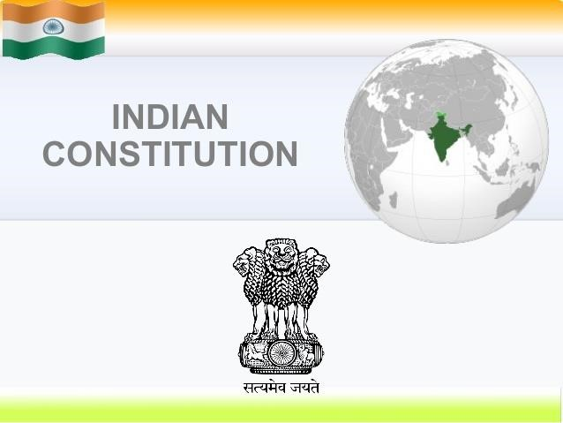

|  |
| --- |
| **CONTENTS** |
| **Evolution of Indian constitution:** Indian independence act 1947, formation of constituent assembly of India, committees of the constituent assembly, constitution of India drafting committee, brief study about Dr. B. R. Ambedkar, time line of formation of the constitution of India.  **Structure of the constitution of India:** Parts, schedules, appendices, constitution and government, constitution and judiciary.  **Preamble to the constitution of India:** Brief study about sovereignty, socialist, secularism, democracy, republic, justice (political justice, social justice, economic justice), liberty, equality, fraternity, unity & integrity.  **Acts:** Right to education act, right to information act, anti-defection law, Jan Lokpal bill.  **Fundamental rights:** Right to equality, right to freedom (freedom of speech and expression, right to practice any profession etc.), right against exploitation, right to freedom of religion, cultural & education rights, right to property, right to constitutional remedies. |

**Text Book:**

* Dr.Durgadasbasu. Introduction to the constitution of India. 21st edition, Lexis Nexis books publication Ltd, 2013.
* **Reference Books:**
* 1. Subhash C. Kashyap, Our Constitution, National Book Trust, New Delhi, 2011.
* 2. Arun K Thiruvengadam. The constitution of

India. 1st edition, Hart publishing India, 2017.

**COURSE OVERVIEW:**

This course enables the students to understand the constitution of India as the Supreme law of India. The student will also gain knowledge about the parliament of India and how it functions. This course will survey the basic structure and operative dimensions of the Indian constitution. It will explore various aspects of the Indian political and legal system from a historical perspective highlighting the various events that led to the making of the Indian constitution.

**COURSE OBJECTIVE:**

This course facilitates graduate students to know about importance of the Indian constitution and facilitates students to know about the fundamental rights of the citizens.

**COURSE OUTCOMES (COs)**

After the completion of the course, the student will be able to:

Identify the important components of Indian Constitution

Apply the fundamental rights in right way and to be a more responsible citizen

Illustrate the evolution of Indian Constitution

Explain the basic structure of Indian Constitution

Define the basic concepts democracy, liberty, equality, secular and justice

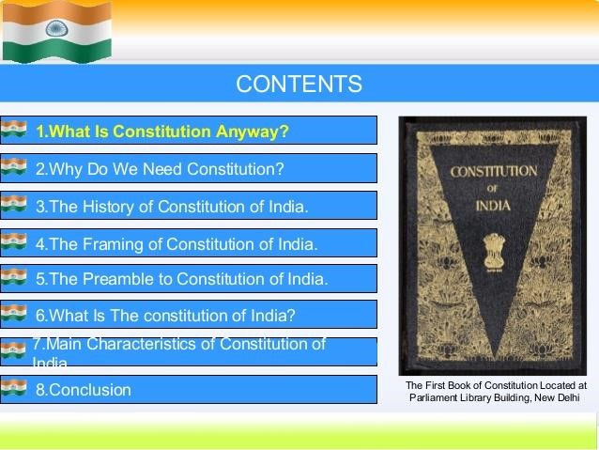

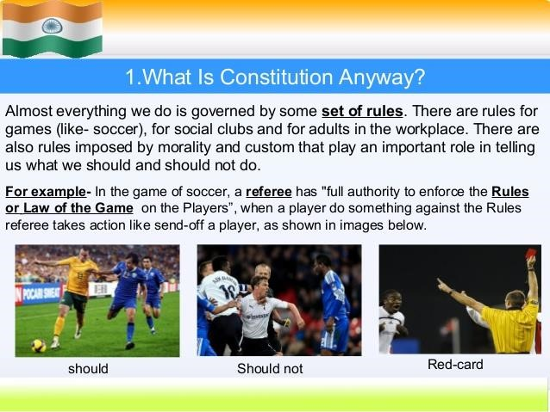

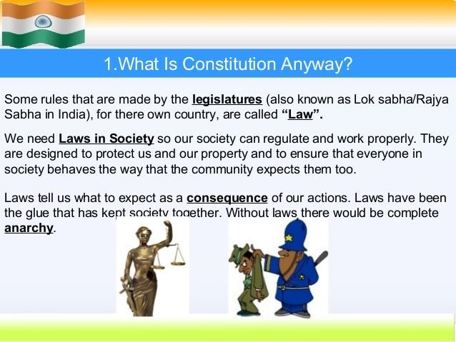

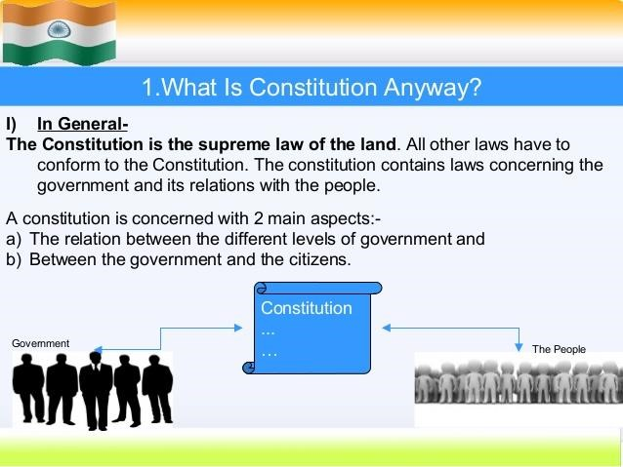

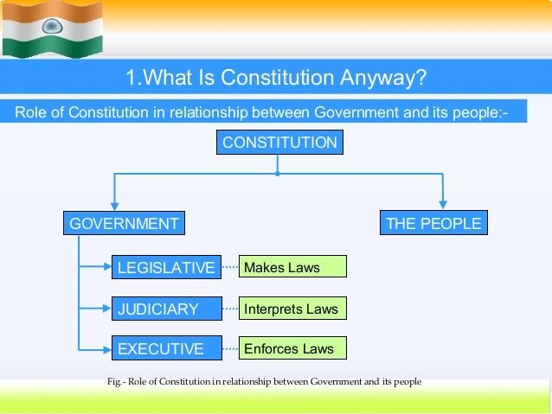

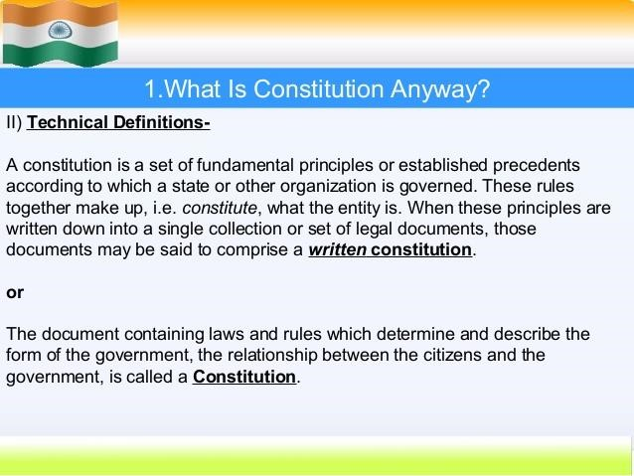

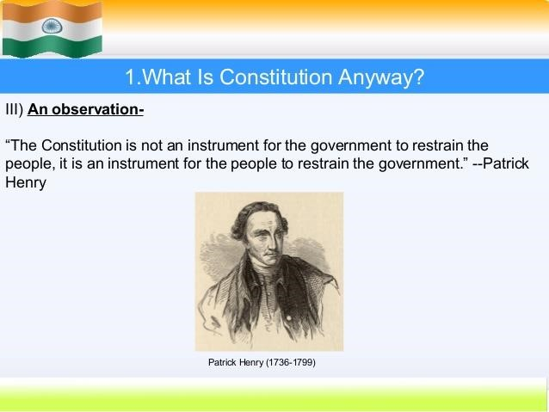

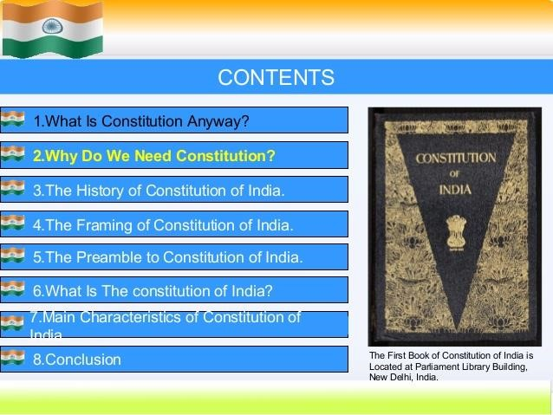

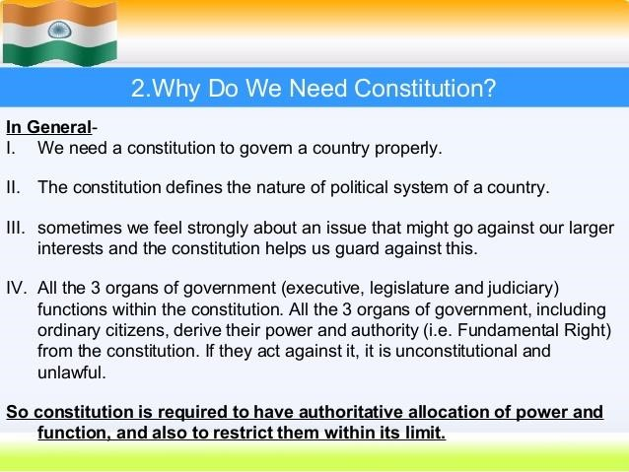

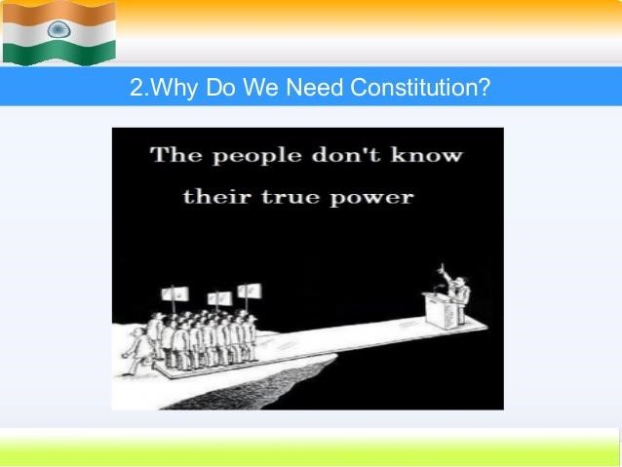

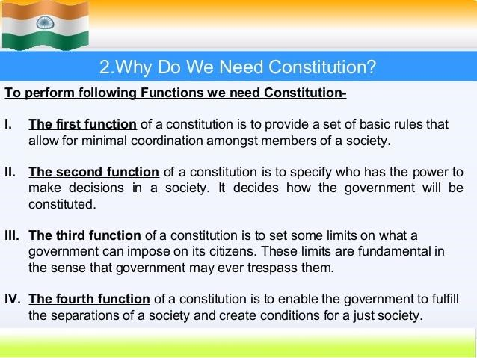

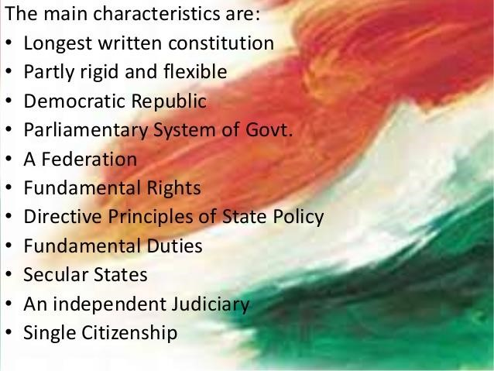

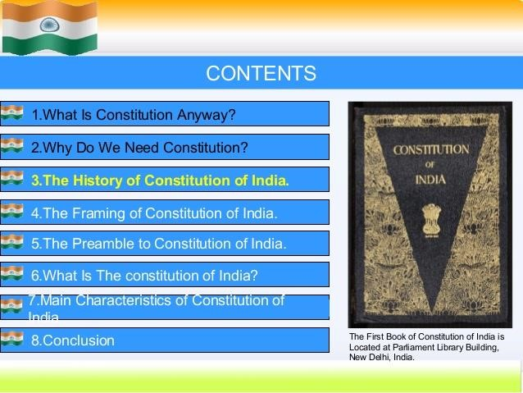

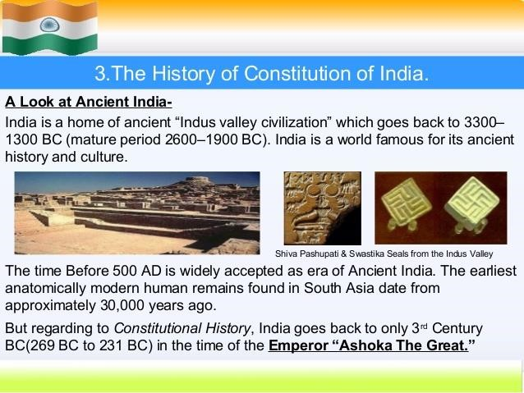

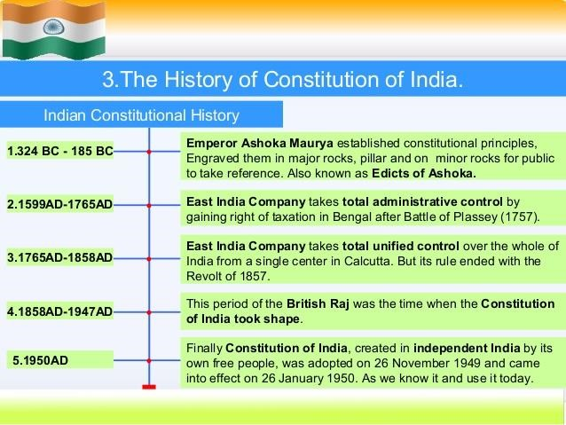

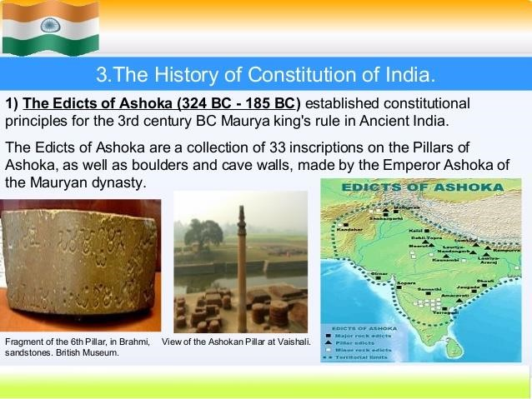

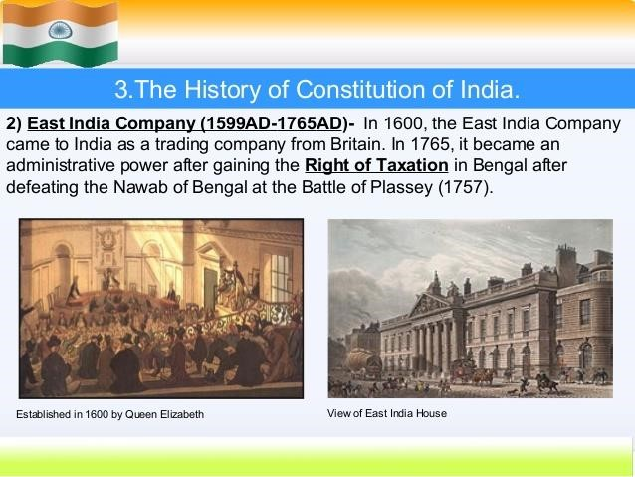

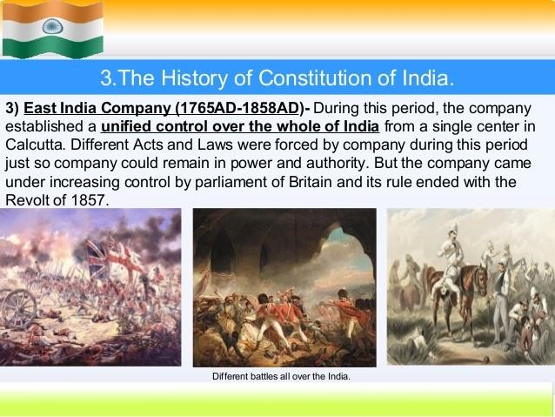

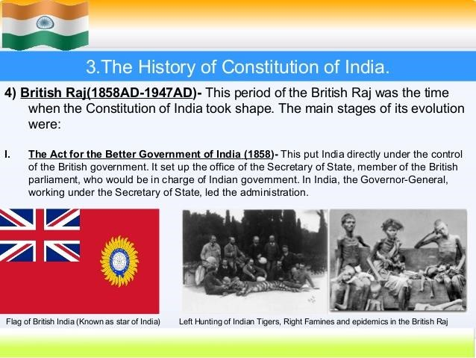

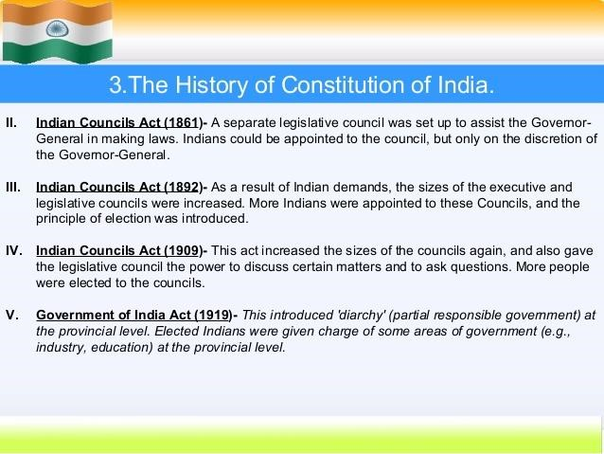

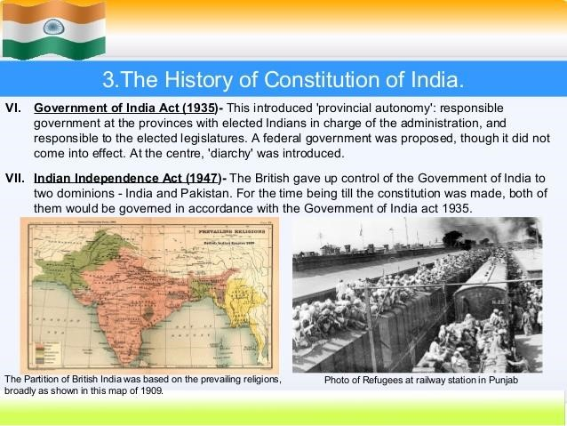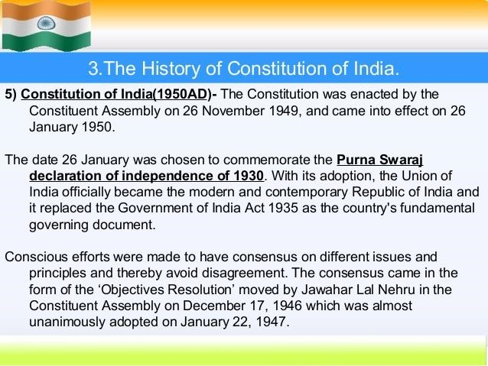

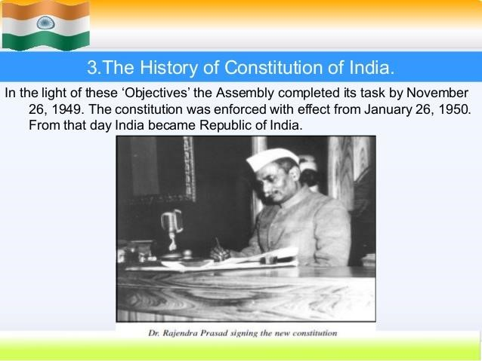

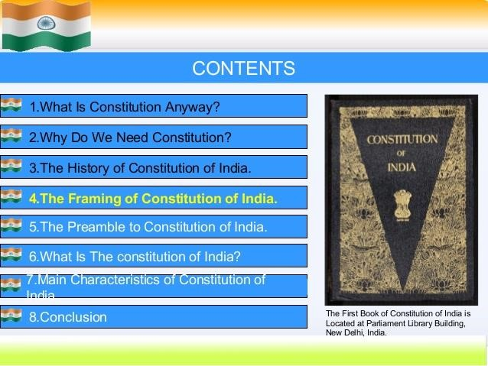



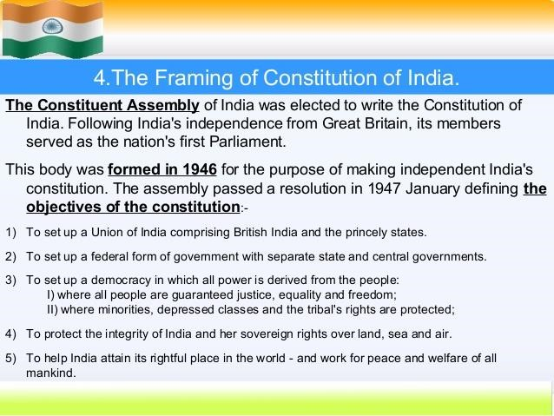

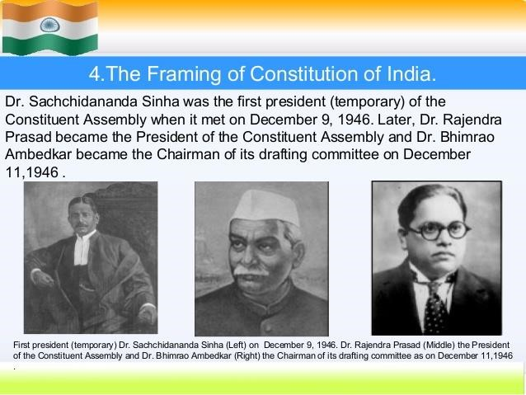

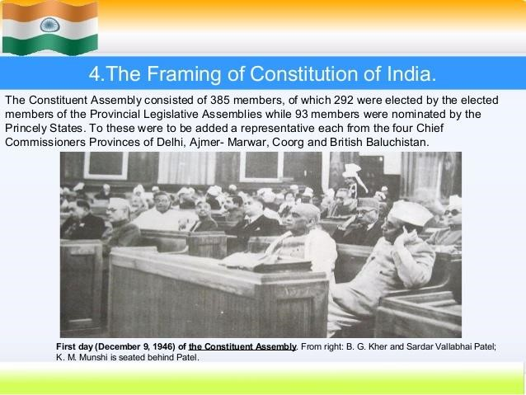

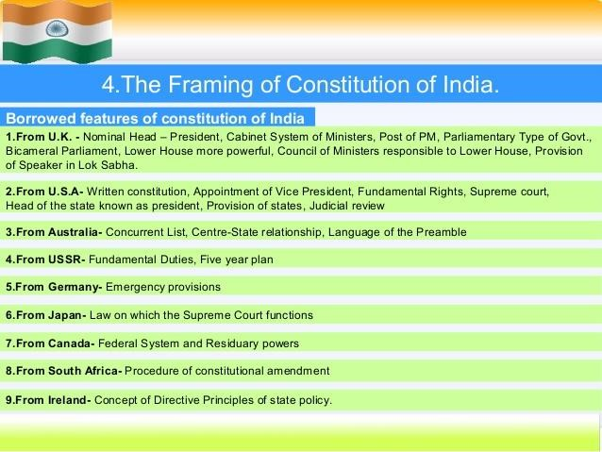

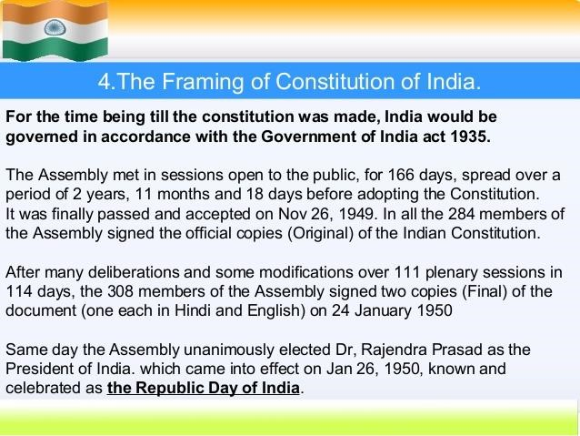

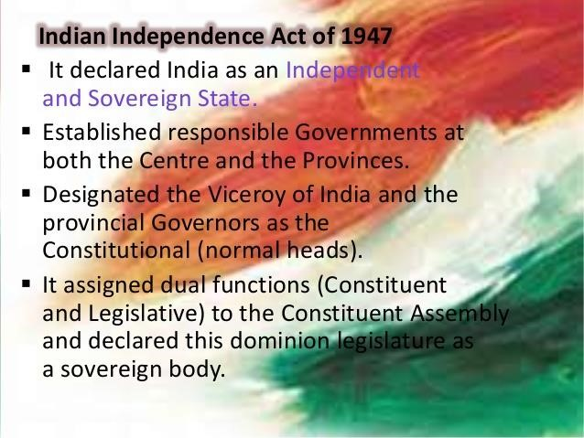

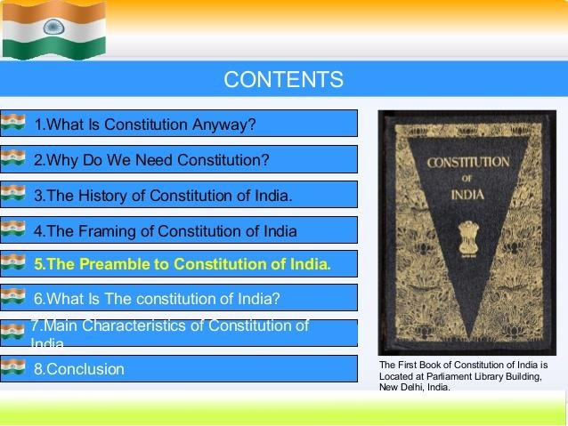

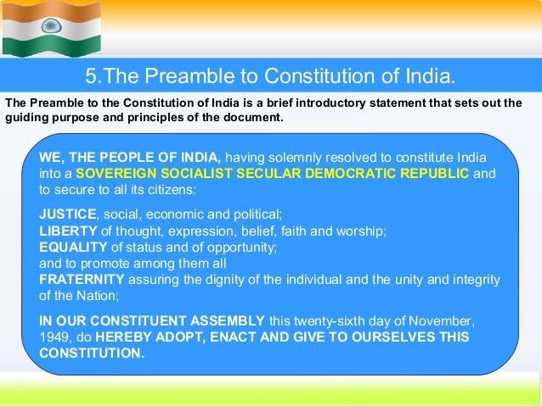

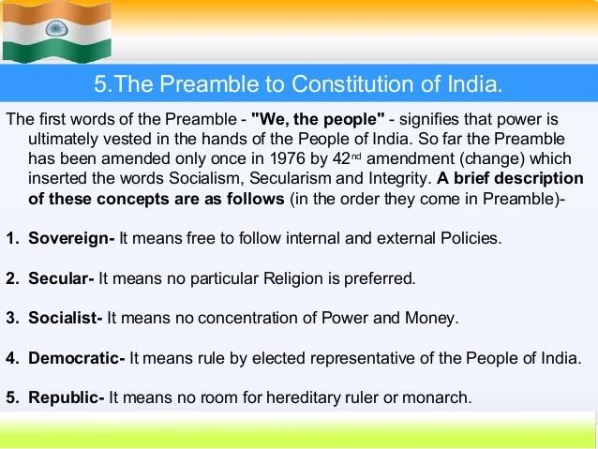

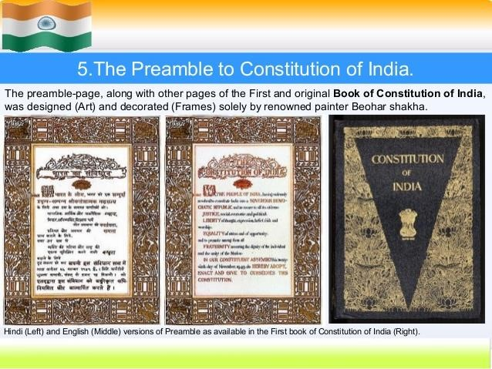

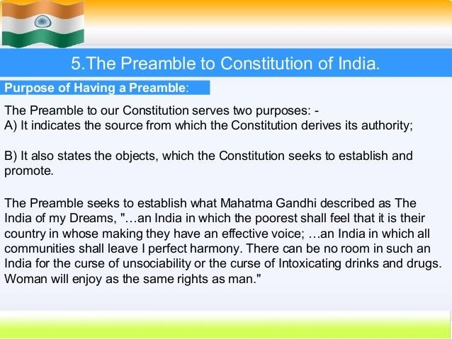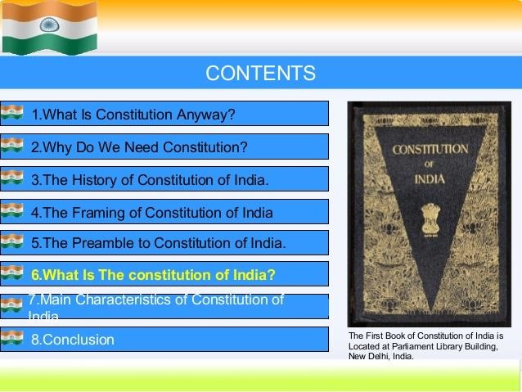

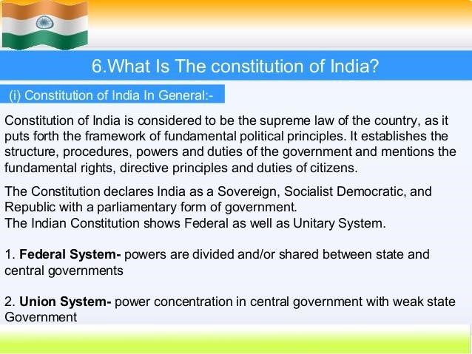

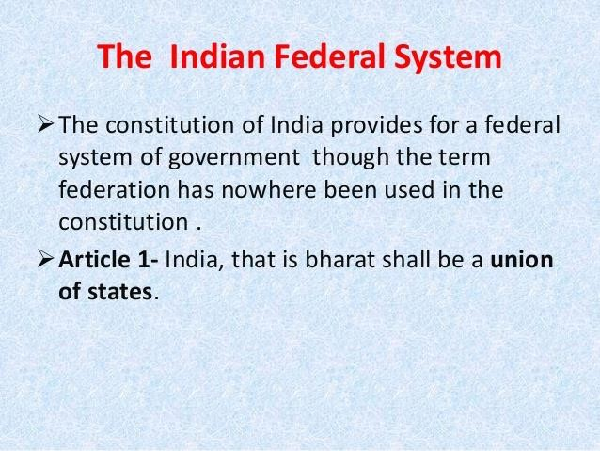

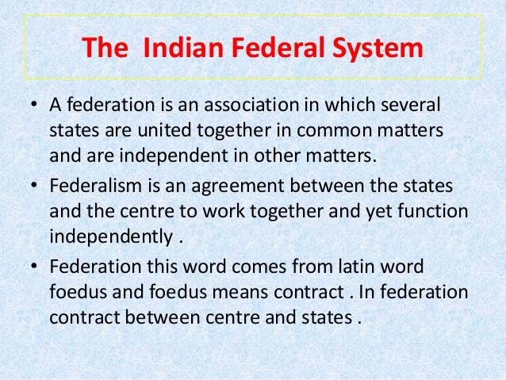

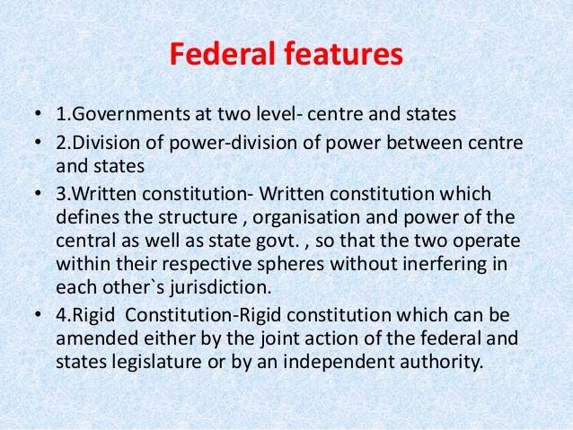

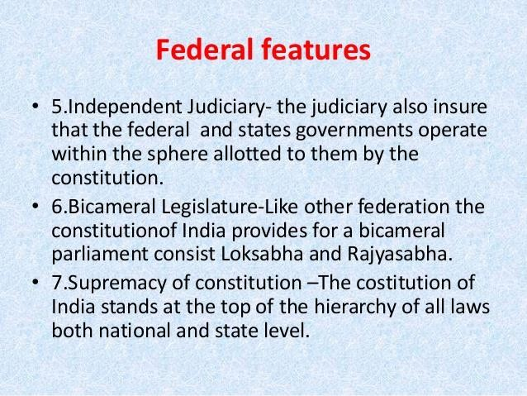

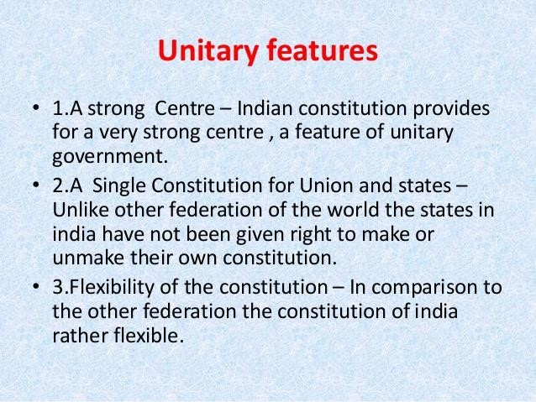

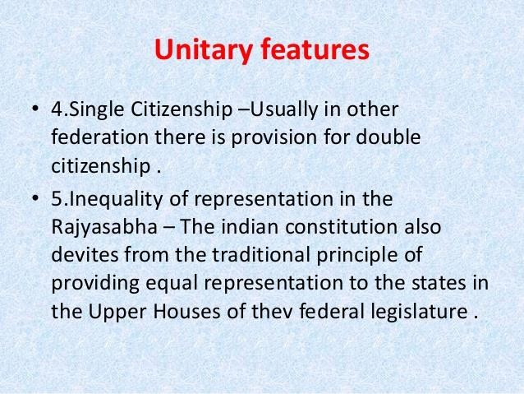

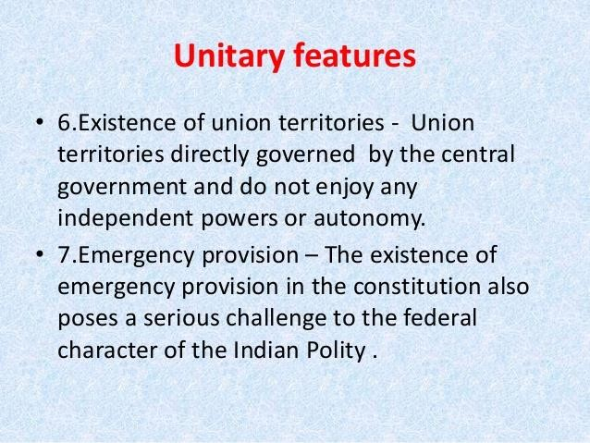

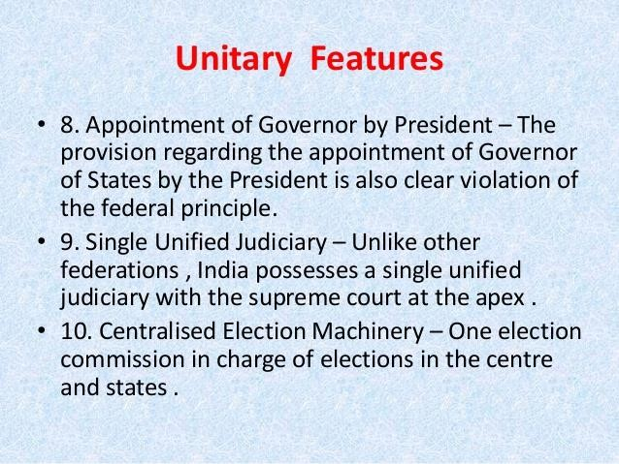

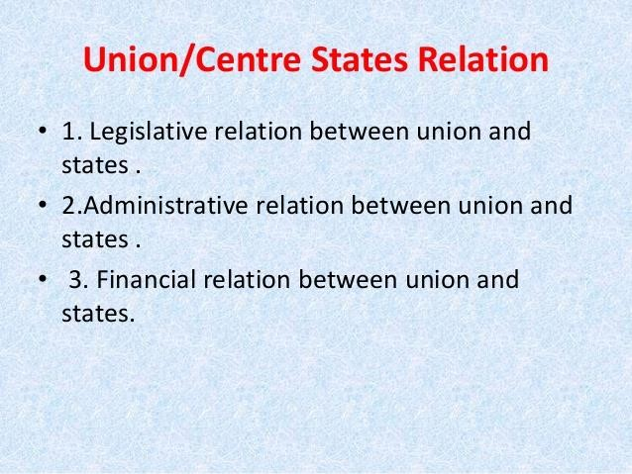

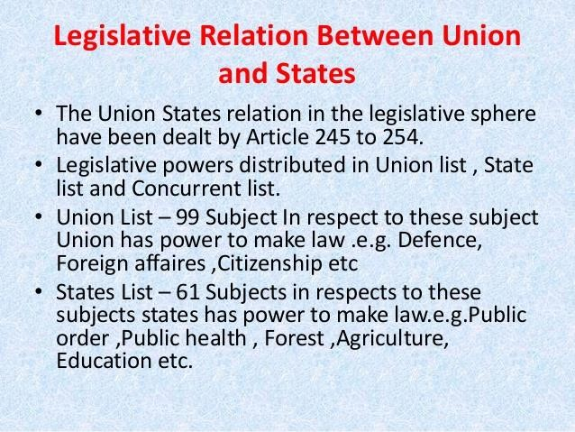

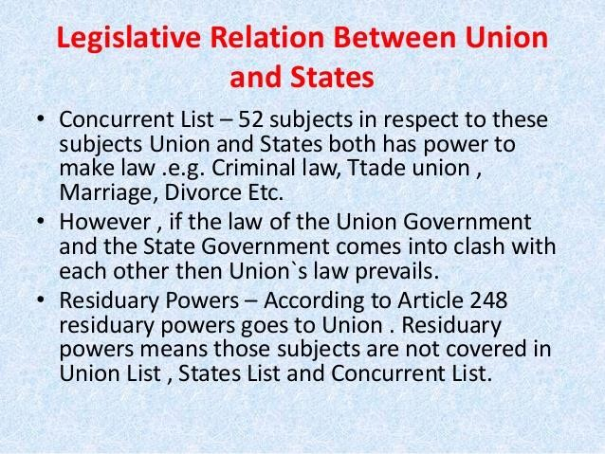

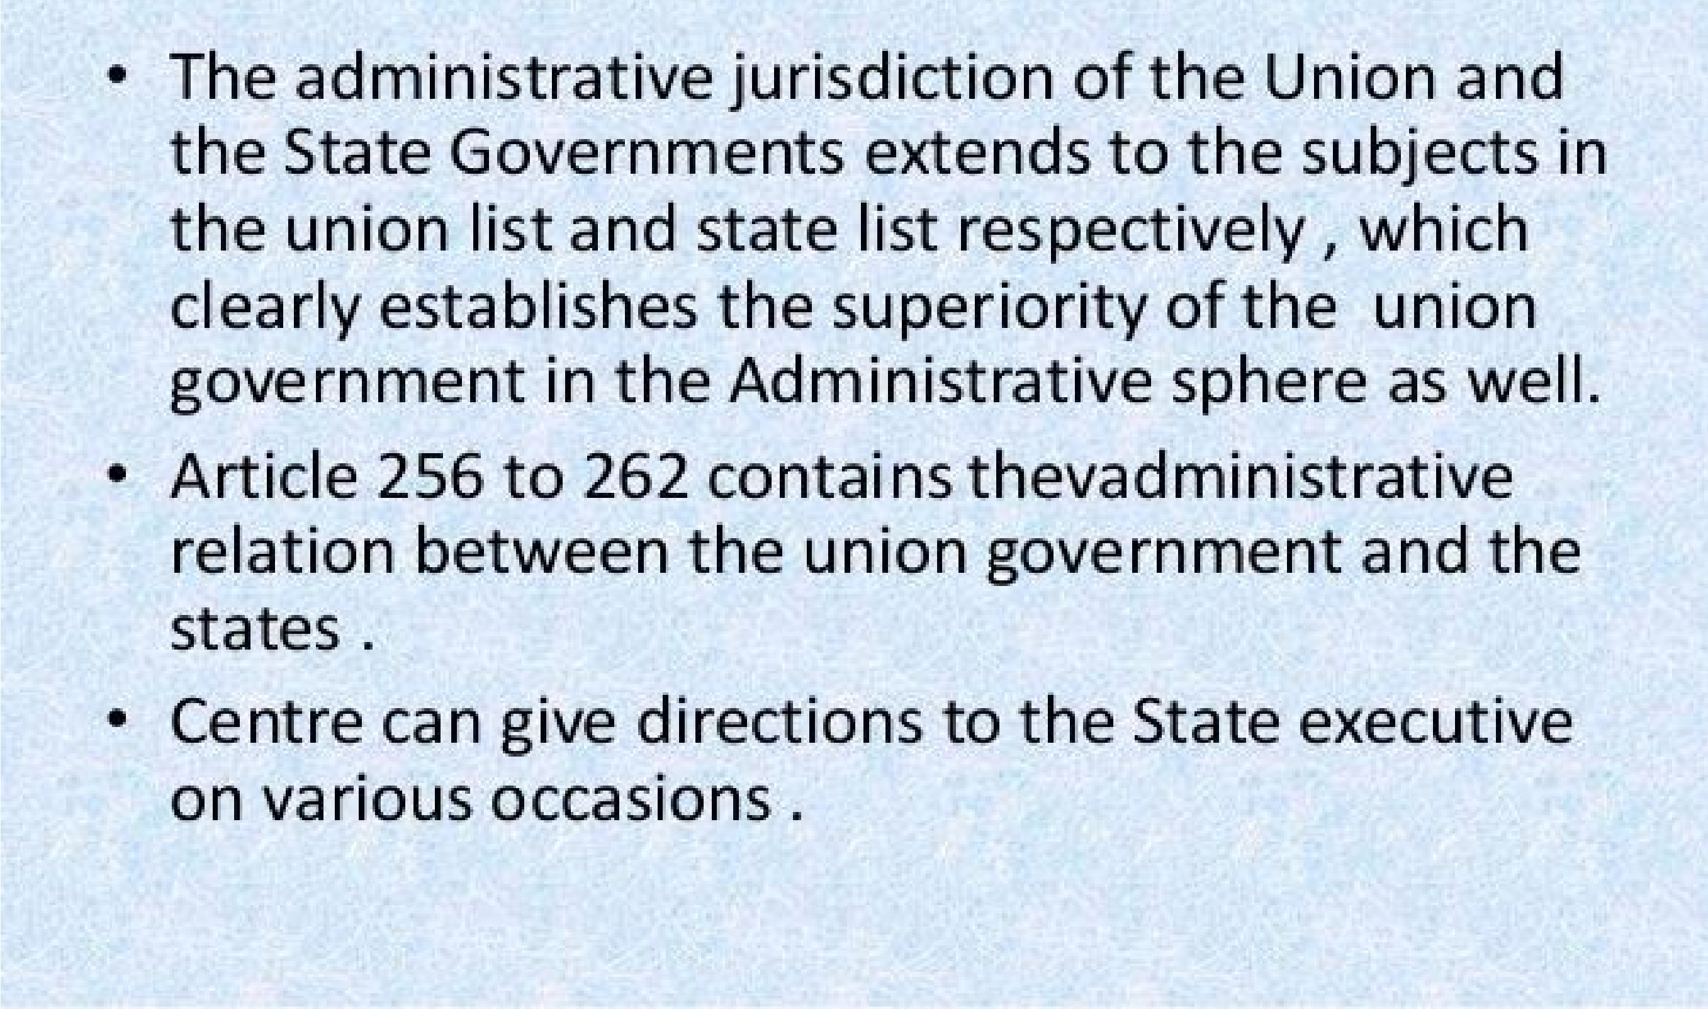

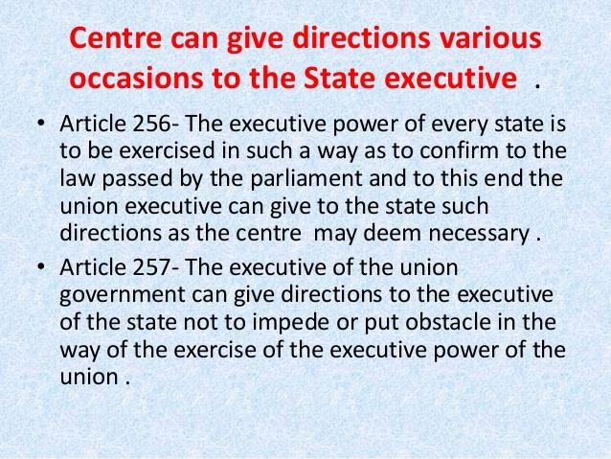

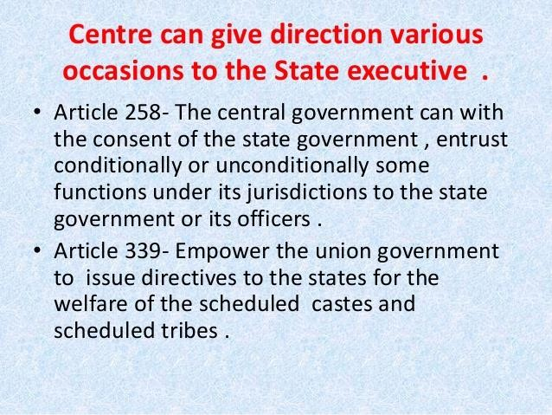

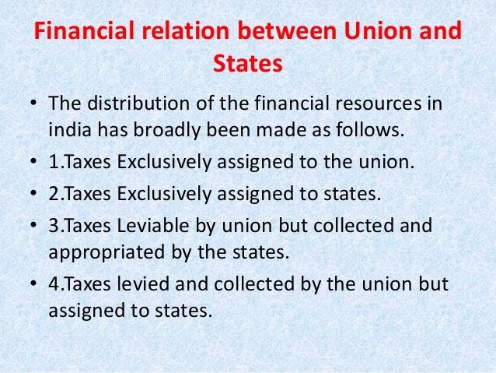

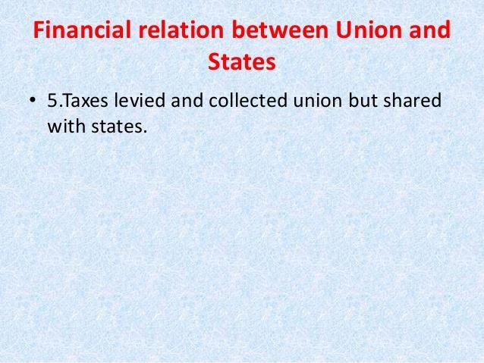

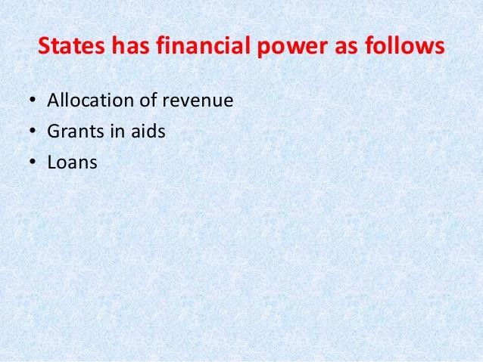



CONSTITUTION OF INDIA

-

STRUCTURE

AND

FEATURES

# BACKGROUND

The Constitution of India was adopted on 26 November 1949 and came into effect on 26 January 1950, proclaiming India to be a sovereign, democratic republic

The federal structure of government, provincial autonomy, a bicameral central legislature consisting of a federal assembly and a Council of States and the separation of legislative powers between the centre and states are some of the provisions of the Act which are present in the Constitution of India.

# DRAFTING

The Constitution was drafted by the Constituent Assembly, which was elected by the electedmembers of the provincialassemblies.

Dr B.R. Ambedkar, Sanjay Phakey, Jawaharlal Nehru, C. Rajagopalachari, Rajendra Prasad, Sardar Vallabhbhai Patel, Maulana Abul Kalam Azad were some importantfigures in theAssembly.

The members of the Constituent Assembly met for the first time on 9 December 1946

On 29 August 1947, the Drafting Committee was appointed, with Dr B. R. Ambedkar as the Chairman along with six other members assisted by a constitutional advisor.

# STRUCTURE

The Constitution, in its current form (September 2012), consists of a preamble, 25 parts containing 463 articles, 12 schedules, 2 appendices and 97 amendments to date (latest being related to co-operative societies added in part IX(B) in 2012).

Indian constitution is federal in nature and also has a strong unitary bias.

22 PARTS

395ARTICLES

12 SCHEDULES

2APPENDICES

92AMENDMENTS

**Parts:**



The individual Articles of the Constitution are grouped together into the following Parts:

## Preamble

**Part I** – Union and its Territory **Part II** – Citizenship.

**Part III** – Fundamental Rights.

**Part IV** – Directive Principles of State Policy.

**Part IVA** – Fundamental Duties.

**Part V**– The Union.

**Part VI**– The States.

**Part VII** – States in the B part of the First schedule*(Repealed)*. **Part VIII** – The Union Territories **Part IX**– The Panchayats.



**Part IXA** – The Municipalities.

**Part IXB** – The Cooperative Societies

**Part X** – The scheduled and TribalAreas

**Part XI** – Relations between the Union and the States.

**Part XII** – Finance, Property, Contracts and Suits

**Part XIII** – Trade and Commerce within the territory of India **Part XIV** – Services Under the Union, the States.



**Part XIVA** – Tribunals.

**Part XV** – Elections

**Part XVI** – Special Provisions Relating to certain Classes.

**Part XVII** – Languages

**Part XVIII** – Emergency Provisions

**Part XIX** – Miscellaneous

**Part XX**– Amendment of the Constitution

**Part XXI**– Temporary, Transitional and Special Provisions

**Part XXII** – Short title, date of commencement, Authoritative text in Hindi and Repeals

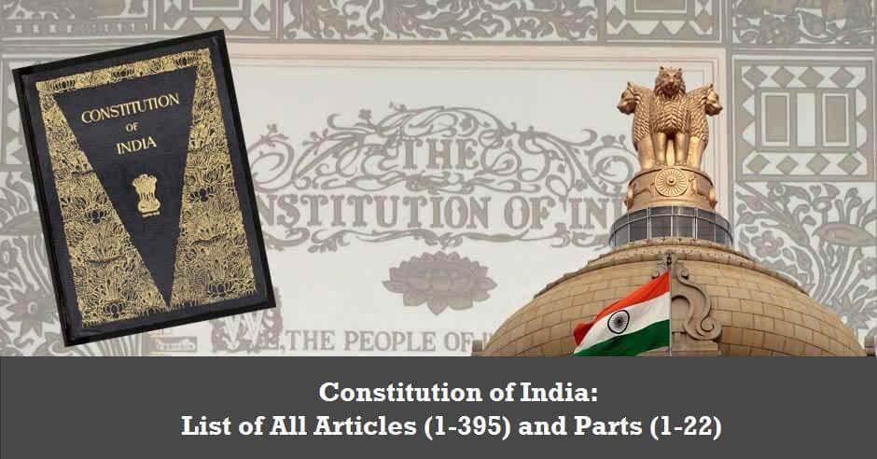

➢Constitution of India contains 395 articles in 22 parts. Additional articles and parts are inserted later through various amendments. There are also 12 schedules in the Indian

Constitution

[**PART I:**](https://www.clearias.com/union-and-its-territory/)[**THE UNION AND ITS TERRITORY**](https://www.clearias.com/union-and-its-territory/)

1. Name and territory of the Union.
2. Admission or establishment of new States.

2A [Repealed.]

1. Formation of new States and alteration of areas, boundaries or names of existing States.
2. Laws made under articles 2 and 3 to provide for the amendment of the First and the Fourth Schedules and supplemental, incidental and consequential matters.

[**PART II:**](https://www.clearias.com/citizenship/)[**CITIZENSHIP**](https://www.clearias.com/citizenship/)

1. Citizenship at the commencement of the Constitution.6 Rights of citizenship of certain persons who have migrated to India from Pakistan.

7 Rights of citizenship of certain migrants to Pakistan. 8 Rights of citizenship of certain persons of Indian origin residing outside India.

1. Persons voluntarily acquiring citizenship of a foreign State not to be citizens.
2. Continuance of the rights of citizenship.
3. Parliament to regulate the right of citizenship by law.

[**PART III :**](https://www.clearias.com/fundamental-rights/)[**FUNDAMENTAL RIGHTS**](https://www.clearias.com/fundamental-rights/)

### General

1. Definition.
2. Laws inconsistent with or in derogation of the fundamental rights.**Right to Equality**
3. Equality before law.
4. Prohibition of discrimination on grounds of religion, race, caste, sex or place of birth.
5. Equality of opportunity in matters of public employment.
6. Abolition of Untouchability.
7. Abolition of titles.

### Right to Freedom

1. Protection of certain rights regarding freedom of speech, etc.
2. Protection in respect of conviction for offences.
3. Protection of life and personal liberty.

21A Right to education

1. Protection against arrest and detention in certain cases.

### Right against Exploitation

1. Prohibition of traffic in human beings and forced labour.
2. Prohibition of employment of children in factories, etc.

Right to Freedom of Religion

1. Freedom of conscience and free profession, practice and propagation of religion.
2. Freedom to manage religious affairs.
3. Freedom as to payment of taxes for promotion of any particular religion.28 Freedom as to attendance at religious instruction or religious worship in certain educational institutions.

### Cultural and Educational Rights

1. Protection of interests of minorities.
2. Right of minorities to establish and administer educational institutions.
3. [Repealed.]

Saving of Certain Laws

31A Saving of Laws providing for the acquisition of estates, etc.

31B Validation of certain Acts and Regulations.

31C Saving of laws giving effect to certain directive principles. 31D [Repealed.]

Right to Constitutional Remedies

1. Remedies for enforcement of rights conferred by this Part.

32A [Repealed.]

1. Power of Parliament to modify the rights conferred by this Part in their application to Forces, etc.
2. Restriction on rights conferred by this Part while martial law is in force in any area.
3. Legislation to give effect to the provisions of this Part.

[PART IV: DIRECTIVE PRINCIPLES OF STATE POLICY](https://www.clearias.com/directive-principles-of-our-state-policy/) 36 Definition.

1. Application of the principles contained in this Part.
2. State to secure a social order for the promotion of the welfare of the people.
3. Certain principles of policy to be followed by the State.

39A Equal justice and free legal aid.

1. The organisation of village panchayats.
2. Right to work, to education and to public assistance in certain cases.
3. Provision for just and humane conditions of work and maternity relief.
4. Living wage, etc., for workers.

43A Participation of workers in the management of industries.

43B Promotion of co-operative societies.

1. Uniform civil code for the citizens.
2. Provision for free and compulsory education for children.
3. Promotion of educational and economic interests of Scheduled Castes, Scheduled Tribes and other weaker sections.
4. Duty of the State to raise the level of nutrition and the standard of living and to improve public health. 48 The organisation of agriculture and animal husbandry.

48A Protection and improvement of environment and safeguarding of forests and wildlife.

1. Protection of monuments and places and objects of national importance.
2. Separation of judiciary from the executive.
3. Promotion of international peace and security.

[**PART IVA: FUNDAMENTAL DUTIES**](https://www.clearias.com/fundamental-duties/) 51A Fundamental duties.

**PART V: THE UNION**

CHAPTER I: THE EXECUTIVE

The President and Vice-President

1. [The President of India](https://www.clearias.com/president-of-india/)
2. The executive power of the Union.
3. Election of President.
4. Manner of election of President.
5. Term of office of President.
6. Eligibility for re-election.
7. Qualifications for election as President.
8. Conditions of the President’s office.
9. Oath or affirmation by the President.
10. Procedure for impeachment of the President.62 Time of holding the election to fill the vacancy in the office of President and the term of office of person elected to fill the casual vacancy.
11. [The Vice-President of India.](https://www.clearias.com/vice-president-of-india/)
12. The Vice-President to be ex officio Chairman of the Council of States.
13. The Vice-President to act as President or to discharge his functions during casual vacancies in the office, or during the absence, of President
14. Election of Vice-President.
15. Term of office of Vice-President.
16. Time of holding the election to fill the vacancy in the office of Vice-President and the term of office of person elected to fill the casual vacancy.
17. Oath or affirmation by the Vice-President.
18. Discharge of President’s functions in other contingencies.71 Matters relating to, or connected with, the election of a President or Vice-President.
19. Power of President to grant pardons, etc., and to suspend, remit or commute sentences in certain cases.
20. The extent of executive power of the Union.

[**Council of Ministers**](https://www.clearias.com/com-prime-minister-attorney-general/)

1. Council of Ministers to aid and advise the President.
2. Other provisions as to Ministers.**The Attorney-General for India** 76 Attorney-General for India.

## Conduct of Government Business

77 Conduct of business of the Government of India. 78 Duties of Prime Minister as respects the furnishing of information to the President, etc.

**CHAPTER II: PARLIAMENT**

[**General**](https://www.clearias.com/parliament/)

1. Constitution of Parliament.
2. Composition of the Council of States.
3. Composition of the House of the People.
4. Readjustment after each census.
5. Duration of Houses of Parliament.
6. Qualification for membership of Parliament.
7. Sessions of Parliament, prorogation and dissolution.
8. Right of President to address and send messages to Houses.
9. Special address by the President.
10. Rights of Ministers and Attorney-General as respects Houses.

[**Officers of Parliament**](https://www.clearias.com/officers-conduct-of-business-disqualification-mps/)

1. The Chairman and Deputy Chairman of the Council of States.
2. Vacation and resignation of, and removal from, the office of Deputy Chairman.
3. Power of the Deputy Chairman or other person to perform the duties of the office of, or to act as, Chairman.
4. The Chairman or the Deputy Chairman not to preside while a resolution for his removal from office is under consideration. 93 The Speaker and Deputy Speaker of the House of the People . 94 Vacation and resignation of, and removal from, the offices of Speaker and Deputy Speaker.
5. Power of the Deputy Speaker or other person to perform the duties of the office of, or to act as, Speaker.
6. The Speaker or the Deputy Speaker not to preside while a resolution for his removal from office is under consideration.
7. Salaries and allowances of the Chairman and Deputy Chairman and the Speaker and Deputy Speaker.
8. Secretariat of Parliament.

## Conduct of Business

1. Oath or affirmation by members.
2. Voting in Houses, power of Houses to act notwithstanding vacancies and quorum.

**Disqualifications of Members**

1. Vacation of seats.
2. Disqualifications for membership.
3. Decision on questions as to disqualifications of members.104 Penalty for sitting and voting before making oath or affirmation under article 99 or when not qualified or when disqualified.

Powers, Privileges and Immunities of Parliament and its Members 105 Powers, privileges, etc., of the Houses of Parliament and of the members and committees thereof.

1. Salaries and allowances of members.

[**Legislative Procedure**](https://www.clearias.com/bills-procedures-parliament/)

1. Provisions as to introduction and passing of Bills.
2. Joint sitting of both Houses in certain cases.
3. Special procedure in respect of Money Bills.
4. Definition of “Money Bills”.111 Assent to Bills.

**Procedure in Financial Matters**

1. Annual financial statement.
2. Procedure in Parliament with respect to estimates.
3. Appropriation Bills.
4. Supplementary, additional or excess grants.
5. Votes on account, votes of credit and exceptional grants.
6. Special provisions as to financial Bills.

**Procedure Generally** 118 Rules of procedure.

1. Regulation by law of procedure in Parliament in relation to financial business.
2. Language to be used in Parliament.
3. Restriction on discussion in Parliament.
4. Courts not to inquire into proceedings of Parliament.

**CHAPTER III: LEGISLATIVE POWERS OF THE PRESIDENT**

1. Power of President to promulgate Ordinances during recess of Parliament

[**CHAPTER IV: THE UNION JUDICIARY**](https://www.clearias.com/union-judiciary-supreme-court/)

1. Establishment and constitution of Supreme Court.124A National Judicial Appointments Commission. *(Declared unconstitutional by the Supreme Court, however not repealed by the Parliament)*

124B Functions of Commission.

124C Power of Parliament to make law.

1. Salaries, etc., of Judges.
2. Appointment of acting Chief Justice.
3. Appointment of ad hoc judges.
4. Attendance of retired Judges at sittings of the Supreme Court.
5. Supreme Court to be a court of record.
6. Seat of Supreme Court.
7. Original jurisdiction of the Supreme Court.

131A [Repealed.]

1. Appellate jurisdiction of Supreme Court in appeals from High Courts in certain cases.
2. Appellate jurisdiction of Supreme Court in appeals from High Courts in regard to Civil matters.
3. Appellate jurisdiction of Supreme Court in regard to criminal matters.

134A Certificate for appeal to the Supreme Court.

1. Jurisdiction and powers of the Federal Court under existing law to be exercisable by the Supreme Court.
2. Special leave to appeal by the Supreme Court.
3. Review of judgments or orders by the Supreme Court.
4. Enlargement of the jurisdiction of the Supreme Court.139 Conferment on the Supreme Court of powers to issue certain writs.

139A Transfer of certain cases.

1. Ancillary powers of Supreme Court.
2. Law declared by Supreme Court to be binding on all courts.
3. Enforcement of decrees and orders of Supreme Court and orders as to discovery, etc.
4. Power of President to consult Supreme Court.
5. Civil and judicial authorities to act in aid of the Supreme Court.

144A [Repealed.]

1. Rules of Court, etc.
2. Officers and servants and the expenses of the Supreme Court.
3. Interpretation.

[**CHAPTER V: COMPTROLLER AND AUDITOR-**](https://www.clearias.com/comptroller-and-auditor-general-of-india-cag/)

[**GENERAL OF INDIA**](https://www.clearias.com/comptroller-and-auditor-general-of-india-cag/)

1. Comptroller and Auditor-General of India. 149 Duties and powers of the Comptroller and Auditor-General.
2. Form of accounts of the Union and of the States.
3. Audit reports.

**PART VI: THE STATES CHAPTER I: GENERAL** 152 Definition.

**CHAPTER II: THE EXECUTIVE**

[**The Governor**](https://www.clearias.com/governor-of-states/)

1. Governors of States.
2. Executive power of State.
3. Appointment of Governor.
4. Term of office of Governor.
5. Qualifications for appointment as Governor.158 Conditions of Governor’s office 159 Oath or affirmation by the Governor.
6. Discharge of the functions of the Governor in certain contingencies.
7. Power of Governor to grant pardons, etc., and to suspend, remit or commute sentences in certain cases.
8. Extent of executive power of State.

**Council of Ministers**

1. Council of Ministers to aid and advise Governor.164 Other provisions as to Ministers. The Advocate-General for the State 165 Advocate-General for the State.

Conduct of Government Business

166 Conduct of business of the Government of a State. 167 Duties of Chief Minister as respects the furnishing of information to Governor, etc.

**CHAPTER III: THE STATE LEGISLATURE**

[**General**](https://www.clearias.com/state-legislature/)

1. Constitution of Legislatures in States.
2. Abolition or creation of Legislative Councils in States.
3. Composition of the Legislative Assemblies.
4. Composition of the Legislative Councils.
5. Duration of State Legislatures.
6. Qualification for membership of the State Legislature.174 Sessions of the State Legislature, prorogation and dissolution.
7. Right of Governor to address and send messages to the House or Houses.
8. Special address by the Governor.
9. Rights of Ministers and Advocate-General as respects the Houses.

[**Officers of the State Legislature**](https://www.clearias.com/officers-of-the-state-legislature/)

1. The Speaker and Deputy Speaker of the Legislative Assembly.
2. Vacation and resignation of, and removal from, the offices of Speaker and Deputy Speaker.
3. Power of the Deputy Speaker or other person to perform the duties of the office of, or to act as, Speaker.
4. The Speaker or the Deputy Speaker not to preside while

a resolution for his removal from office is under consideration.

1. The Chairman and Deputy Chairman of the Legislative Council.
2. Vacation and resignation of, and removal from, the offices of Chairman and Deputy Chairman.
3. Power of the Deputy Chairman or other person to perform the duties of the office of, or to act as, Chairman.
4. The Chairman or the Deputy Chairman not to preside while a resolution for his removal from office is under consideration.
5. Salaries and allowances of the Speaker and Deputy Speaker and the Chairman and Deputy Chairman.
6. Secretariat of State Legislature.

### Conduct of Business

1. Oath or affirmation by members.
2. Voting in Houses, power of Houses to act notwithstanding vacancies and quorum.

**Disqualifications of Members** 190 Vacation of seats.

1. Disqualifications for membership.
2. Decision on questions as to disqualifications of members.
3. Penalty for sitting and voting before making oath or affirmation under article

**Powers, privileges and immunities of State Legislatures and their Members**

1. Powers, privileges, etc., of the Houses of Legislatures and of the members and committees thereof. 195 Salaries and allowances of members.

**Legislative Procedure**

1. Provisions as to introduction and passing of Bills.
2. Restriction on powers of Legislative Council as to Bills other than Money Bills.
3. Special procedure in respect of Money Bills.
4. Definition of “Money Bills”.
5. Assent to Bills.
6. Bills reserved for consideration.

**Procedure in Financial Matters**

1. Annual financial statement.
2. Procedure in Legislature with respect to estimates.
3. Appropriation Bills.
4. Supplementary, additional or excess grants.
5. Votes on account, votes of credit and exceptional grants.
6. Special provisions as to financial Bills.

**Procedure Generally** 208 Rules of procedure.

1. Regulation by law of procedure in the Legislature of the State in relation to financial business.
2. Language to be used in the Legislature.
3. Restriction on discussion in the Legislature.
4. Courts not to inquire into proceedings of the Legislature.

**CHAPTER IV : LEGISLATIVE POWER OF THE GOVERNOR** 213 Power of Governor to promulgate Ordinances during recess of Legislature.

**CHAPTER V: THE HIGH COURTS IN THE STATES** 214 High Courts for States.

1. High Courts to be courts of record.
2. Constitution of High Courts.
3. Appointment and conditions of the office of a Judge of a High Court.
4. Application of certain provisions relating to Supreme Court to High Courts.
5. Oath or affirmation by Judges of High Courts.220 Restriction on practice after being a permanent Judge.
6. Salaries, etc., of Judges.
7. Transfer of a Judge from one High Court to another.
8. Appointment of acting Chief Justice.
9. Appointment of additional and acting Judges.

224A Appointment of retired Judges at sittings of High Courts.

1. Jurisdiction of existing High Courts.
2. Power of High Courts to issue certain writs.

226A [Repealed..]

1. Power of superintendence over all courts by the High Court.
2. Transfer of certain cases to High Court.

228A [Repealed.]

1. Officers and servants and the expenses of High Courts.
2. Extension of jurisdiction of High Courts to Union territories.
3. Establishment of a common High Court for two or more States.

**CHAPTER VI : SUBORDINATE COURTS** 233 Appointment of district judges. 233A Validation of appointments of, and judgments, etc., delivered by, certain district judges.

1. Recruitment of persons other than district judges to the judicial service.
2. Control over subordinate courts.
3. Interpretation.
4. Application of the provisions of this Chapter to certain class or classes of magistrates.

**PART VII: THE STATES IN PART B OF THE FIRST SCHEDULE** 238 [Repealed.]

**PART VIII: THE UNION TERRITORIES**

1. Administration of Union territories.

239A Creation of local Legislatures or Council of Ministers or both for certain Union territories.

239AA Special provisions with respect to Delhi.

239AB Provision in case of failure of constitutional machinery. 239B Power of the administrator to promulgate Ordinances during recess of Legislature.

1. Power of President to make regulations for certain Union territories.
2. High Courts for Union territories.242 [Repealed.]

### PART IX: THE PANCHAYATS

1. Definitions.

243A Gram Sabha.

243B Constitution of Panchayats.

243C Composition of Panchayats. 243D Reservation of seats.

243E Duration of Panchayats, etc.

243F Disqualifications for membership.

243G Powers, authority and responsibilities of Panchayats.

243H Powers to impose taxes by, and Funds of, the Panchayats.

243-I Constitution of Finance Commission to review financial position.

243J Audit of accounts of Panchayats.

243K Elections to the Panchayats.

243L Application to Union territories.

243M Part not to apply to certain areas.

243N Continuance of existing laws and Panchayats.

243-O Bar to interference by courts in electoral matters.

**PART IXA: THE MUNICIPALITIES** 243P Definitions.

243Q Constitution of Municipalities. 243R Composition of Municipalities.

243S Constitution and composition of Wards Committees, etc.

243T Reservation of seats.

243U Duration of Municipalities, etc.

243V Disqualifications for membership.

243W Powers, authority and responsibilities of Municipalities, etc.

243X. Power to impose taxes by, and Funds of, the Municipalities.

243 Finance Commission.

243Z Audit of accounts of Municipalities.

243ZA Elections to the Municipalities.

243ZB Application to Union territories.

243ZC Part not to apply to certain areas.

243ZD Committee for district planning.

243ZE Committee for Metropolitan planning.

243ZF Continuance of existing laws and Municipalities.

243ZGBar to interference by Courts in electoral matters.

### PART IXB: THE CO-OPERATIVE SOCIETIES

243ZH Definitions

243ZI Incorporation of co-operative societies

243ZJ Number and term of members of the board and its office bearers.

243 ZK Election of members of board.

243ZL Supersession and suspension of the board and interim management.

243ZM Audit of accounts of co-operative societies. 243ZN Convening of general body meetings. 243ZO Right of a member to get information, 243ZP Returns.

243ZQ Offences and penalties.

243ZR Application to multi-state co-operative societies.

243ZS Application to Union Territories.

243ZT Continuance of existing laws.

**PART X: THE SCHEDULED AND TRIBAL AREAS**

1. Administration of Scheduled Areas and Tribal Areas.

244A Formation of an autonomous State comprising certain tribal areas in Assam and creation of local Legislature or Council of Ministers or both therefor.

**PART XI: RELATIONS BETWEEN THE UNION AND THE STATES**

**CHAPTER I: LEGISLATIVE RELATIONS**

**Distribution of Legislative Powers**

1. Extent of laws made by Parliament and by the Legislatures of States.
2. Subject-matter of laws made by Parliament and by the Legislatures of States.

246A Special provision with respect to goods and services tax. 247 Power of Parliament to provide for the establishment of certain additional courts.

1. Residuary powers of legislation.
2. Power of Parliament to legislate with respect to a matter in the State List in the national interest.
3. Power of Parliament to legislate with respect to any matter in the State List if a Proclamation of Emergency is in operation. 251 Inconsistency between laws made by Parliament under articles 249 and 250 and laws made by the Legislatures of States.

252 Power of Parliament to legislate for two or more States by consent and adoption of such legislation by any other State. 253 Legislation for giving effect to international agreements. 254 Inconsistency between laws made by Parliament and laws made by the Legislatures of States.

1. Requirements as to recommendations and previous sanctions to be regarded as matters of procedure only.

**CHAPTER II : ADMINISTRATIVE RELATIONS**

**General**

1. Obligation of States and the Union.
2. Control of the Union over States in certain cases.

257A [Repealed.]

1. Power of the Union to confer powers, etc., on States in certain cases.

258A Power of the States to entrust functions to the Union.

1. [Repealed.]
2. Jurisdiction of the Union in relation to territories outside India.
3. Public acts, records and judicial proceedings.

## Disputes relating to Waters

1. Adjudication of disputes relating to waters of interState rivers or river valleys.

Co-ordination between States

1. Provisions with respect to an inter-State Council.

## PART XII: FINANCE, PROPERTY, CONTRACTS AND SUITS CHAPTER I: FINANCE General

1. Interpretation.
2. Taxes not to be imposed save by authority of law.266 Consolidated Funds and public accounts of India and of the States.
3. Contingency Fund. Distribution of Revenues between the Union and the States
4. Duties levied by the Union but collected and appropriated by the State. 268A [Repealed.]
5. Taxes levied and collected by the Union but assigned to the States.

269A Levy and collection of goods and services tax in the course of inter-state trade or commerce.

1. Taxes levied and distributed between the Union and the States.
2. Surcharge on certain duties and taxes for purposes of the Union.
3. [Repealed.]
4. Grants in lieu of export duty on jute and jute products.274 Prior recommendation of President required to Bills affecting taxation in which States are interested.
5. Grants from the Union to certain States.
6. Taxes on professions, trades, callings and employments.
7. Savings.
8. [Repealed.]
9. Calculation of “net proceeds”, etc.

279A Goods and Services Tax Council.

1. Finance Commission.
2. Recommendations of the Finance Commission.

**Miscellaneous financial provisions**

1. Expenditure defrayable by the Union or a State out of its revenues.
2. Custody, etc., of Consolidated Funds, Contingency Funds and moneys credited to the public accounts.
3. Custody of suitors’ deposits and other moneys received by public servants and courts.
4. Exemption of property of the Union from State taxation.
5. Restrictions as to imposition of tax on the sale or purchase of goods.
6. Exemption from taxes on electricity.
7. Exemption from taxation by States in respect of water or electricity in certain cases.
8. Exemption of property and income of a State from Union taxation.
9. Adjustment in respect of certain expenses and pensions.

290A Annual payment to certain Devaswom Funds. 291 [Repealed.]

**CHAPTER II: BORROWING**

1. Borrowing by the Government of India.
2. Borrowing by States.

**CHAPTER III: PROPERTY, CONTRACTS, RIGHTS, LIABILITIES, OBLIGATIONS AND SUITS**

1. Succession to property, assets, rights, liabilities and obligations in certain cases.
2. Succession to property, assets, rights, liabilities and obligations in other cases.
3. Property accruing by escheat or laps or as bona vacantia. 297 Things of value within territorial waters or continental shelf and resources of the exclusive economic zone to vest in the Union.
4. Power to carry on trade, etc.
5. Contracts.
6. Suits and proceedings.

**CHAPTER IV: RIGHT TO PROPERTY**

300A Persons not to be deprived of property save by authority of law.

## PART XIII: TRADE, COMMERCE AND INTERCOURSE WITHIN THE TERRITORY OF INDIA

301 Freedom of trade, commerce and intercourse. 302 Power of Parliament to impose restrictions on trade, commerce and intercourse.

303 Restrictions on the legislative powers of the Union and of the States with regard to trade and commerce. 304 Restrictions on trade, commerce and intercourse among States.

305 Saving of existing laws and laws providing for State monopolies. 306 [Repealed.]

307 Appointment of authority for carrying out the purposes of articles 301 to 304.

**PART XIV: SERVICES UNDER THE UNION AND THE STATES CHAPTER I: SERVICES** 308 Interpretation.

1. Recruitment and conditions of service of persons serving the Union or a State.
2. Tenure of office of persons serving the Union or a State.311 Dismissal, removal or reduction in rank of persons employed in civil capacities under the Union or a State.
3. All-India services.

312A Power of Parliament to vary or revoke conditions of service of officers of certain services.

1. Transitional provisions.314 [Repeated.]

**CHAPTER II: PUBLIC SERVICE COMMISSIONS**

1. Public Service Commissions for the Union and for the States.
2. Appointment and term of office of members.
3. Removal and suspension of a member of a Public Service Commission.
4. Power to make regulations as to conditions of service of members and staff of the Commission.
5. Prohibition as to the holding of offices by members of Commission on ceasing to be such members.
6. Functions of Public Service Commissions.321 Power to extend functions of Public Service Commissions.
7. Expenses of Public Service Commissions.
8. Reports of Public Service Commissions.

**PART XIVA: TRIBUNALS**

323A Administrative tribunals.

323B Tribunals for other matters.

**PART XV: ELECTIONS**

1. Superintendence, direction and control of elections to be vested in an Election Commission.
2. No person to be ineligible for inclusion in, or to claim to be included in a special, electoral roll on grounds of religion, race, caste or sex.
3. Elections to the House of the People and to the Legislative Assemblies of States to be on the basis of adult suffrage. 327 Power of Parliament to make provision with respect to elections to Legislatures.
4. Power of Legislature of a State to make provision with respect to elections to such Legislature.
5. Bar to interference by courts in electoral matters.

329A [Repealed.]

**PART XVI: SPECIAL PROVISIONS RELATING TO CERTAIN CLASSES** 330 Reservation of seats for Scheduled Castes and Scheduled Tribes in the House of the People.

1. Representation of the Anglo-Indian community in the House of the People.
2. Reservation of seats for Scheduled Castes and Scheduled Tribes in the Legislative Assemblies of the States.
3. Representation of the Anglo-Indian community in the Legislative Assemblies of the States.
4. Reservation of seats and special representation to cease after sixty years.
5. Claims of Scheduled Castes and Scheduled Tribes to services and posts.
6. Special provision for Anglo-Indian community in certain services. 337 Special provision with respect to educational grants for the benefit of the Anglo-Indian Community.
7. National Commission for Scheduled Castes.

338A National Commission for Scheduled Tribes.

338A National Commission for Backward Classes.

1. Control of the Union over the Administration of Scheduled Areas and the welfare of Scheduled Tribes. 340 Appointment of a Commission to investigate the conditions of backward classes.
2. Scheduled Castes.
3. Scheduled Tribes.

342A Socially and educationally backward classes.

**PART XVII: OFFICIAL LANGUAGE CHAPTER I: LANGUAGE OF THE UNION** 343 Official language of the Union.

344 Commission and Committee of Parliament on official language.

## CHAPTER II: REGIONAL LANGUAGES

1. Official language or languages of a State.
2. Official language for communication between one State and another or between a State and the Union. 347 Special provision relating to language spoken by a section of the population of a State.

**CHAPTER III: LANGUAGE OF THE SUPREME COURT, HIGH COURTS, ETC.**

1. Language to be used in the Supreme Court and in the High Courts and for Acts, Bills, etc.
2. Special procedure for enactment of certain laws relating to language.

## CHAPTER IV: SPECIAL DIRECTIVES

1. Language to be used in representations for redress of grievances.

350A Facilities for instruction in mother-tongue at the primary stage.

350B Special Officer for linguistic minorities.

1. Directive for development of the Hindi language.

**PART XVIII: EMERGENCY PROVISIONS** 352 Proclamation of Emergency.

1. Effect of Proclamation of Emergency.
2. Application of provisions relating to distribution of revenues while a Proclamation of Emergency is in operation. 355 Duty of the Union to protect States against external aggression and internal disturbance.
3. Provisions in case of failure of constitutional machinery in States.
4. Exercise of legislative powers under Proclamation issued under article 356.
5. Suspension of provisions of article 19 during emergencies.359 Suspension of the enforcement of the rights conferred by Part III during emergencies.

359A [Repealed.]

1. Provisions as to financial emergency.

**PART XIX: MISCELLANEOUS**

1. Protection of President and Governors and Rajprakukhs. 361A Protection of publication of proceedings of Parliament and State Legislatures.

361B Disqualification for appointment on remunerative political post.

1. [Repealed.]
2. Bar to interference by courts in disputes arising out of certain treaties, agreements, etc.

363A Recognition granted to Rulers of Indian States to cease and privy purses to be abolished.

1. Special provisions as to major ports and aerodromes.365 Effect of failure to comply with, or to give effect to, directions given by the Union.
2. Definitions.
3. Interpretation.

**PART XX: AMENDMENT OF THE CONSTITUTION**

1. Power of Parliament to amend the Constitution and procedure therefor.

**PART XXI: TEMPORARY, TRANSITIONAL AND SPECIAL**

**PROVISIONS**

1. Temporary power to Parliament to make laws with respect to certain matters in the State List as if they were matters in the Concurrent List.
2. Temporary provisions with respect to the State of Jammu and Kashmir.
3. Special provision with respect to the States of Maharashtra and Gujarat.

371A Special provision with respect to the State of Nagaland.

371B Special provision with respect to the State of Assam.

371C Special provision with respect to the State of Manipur. 371D Special provisions with respect to the State of Andhra Pradesh.

371E Establishment of Central University in Andhra Pradesh.

371F Special provisions with respect to the State of Sikkim.

371G Special provision with respect to the State of Mizoram. 371H Special provision with respect to the State of Arunachal Pradesh.

371-I Special provision with respect to the State of Goa.

371J Special provision with respect to the State of Karnataka.

1. Continuance in force of existing laws and their adaptation.

372A Power of the President to adapt laws.

1. Power of President to make order in respect of persons under preventive detention in certain cases. 374 Provisions as to Judges of the Federal Court and proceedings pending in the Federal Court or before His Majesty in Council.
2. Courts, authorities and officers to continue to function subject to the provisions of the Constitution.
3. Provisions as to Judges of High Courts.
4. Provisions as to Comptroller and Auditor-General of India.
5. Provisions as to Public Service Commissions.

378A Special provision as to the duration of Andhra Pradesh Legislative Assembly.

379-391 [Repealed.]

1. Power of the President to remove difficulties.

**PART XXII: SHORT TITLE, COMMENCEMENT, AUTHORITATIVE**

**TEXT IN HINDI AND REPEALS**

1. Short title.
2. Commencement.

394A Authoritative text in the Hindi language.

1. Repeals.

Schedules:

Schedules are lists in the Constitution that categorize and tabulate bureaucratic activity and policy of theGovernment.

**First Schedule** (Articles 1 and 4)- This lists the states and territories of India, lists any changes to their bordersand the laws used to make thatchange.

**Second Schedule** (Articles 59, 65, 75, 97, 125, 148, 158, 164, 186 and 221)This lists the salaries of officials holding public office, judges, and ComptrollerandAuditor-GeneralofIndia.

**Third Schedule** (Articles 75, 99, 124, 148, 164, 188 and 219)—Forms of Oaths – This lists the oathsof offices for electedofficials andjudges.

**Fourth Schedule** (Articles 4 and 80) – This details the allocation of seats in the Rajya Sabha(the upper house of Parliament)per Stateor UnionTerritory.

**Fifth Schedule** (Article 244) – This provides for the administration and control of Scheduled Areas and Scheduled Tribes (areas and tribes needing special protectiondue to disadvantageousconditions).

**Sixth Schedule** (Articles 244 and 275)— Provisions for the administration of tribal areas in Assam, Meghalaya,Tripura, andMizoram.

**Seventh Schedule** (Article 246)—The union (central government), state, and concurrentlistsof responsibilities.

**Eighth Schedule** (Articles 344 and 351)—The officiallanguages.

**Ninth Schedule** (Article 31-B) –Articles mentioned here are immune from judicial review.

**Tenth Schedule** (Articles 102 and 191)—"Anti-defection" provisions for Members of Parliament and Members of the StateLegislatures.

**Eleventh Schedule** (Article 243-G)—*Panchayat Raj* (rural local government).

**Twelth Schedule** (Article 243-W)—Municipalities (urban local government).

**System of government:**

The basic form of the Union Government envisaged in the Constitution

➢**FederalStructure**

Three subject lists, the Union list, the State list, and the Concurrent list, define the legislative powers of each level of government.

The Union government reserves the right to make laws in areas specified on the Union list, the state governments allowed to make laws in areas specified on the State list.

### Parliamentary Democracy

The President of India is elected by the Parliament and State

Legislative Assemblies, and not directly by the people. The President is the head of state, and all the business of the Executive and Laws of the Parliament are in his/her name

The Prime Minister and the Council of Ministers exercise their offices only as long as they enjoy a majority support in the Lok Sabha, the lower house of the Parliament, which consists of members directly elected by the people

A similar structure is present in States, where the directly elected Legislative Assembly enjoys control over the Chief

Minister and the State Council of Ministers

### Independent Judiciary

The Judiciary of India is free of control from either the executive or the Parliament.

The judiciary acts as an interpreter of the constitution, and as an intermediary in case of disputes between two States, or between a State and the Union.

An act passed by the Parliament or a Legislative Assembly is subject to judicial review, and can be declared unconstitutional by the judiciary if it feels that the act violates the provisions of the Constitution.

Salient Features of the constitution of India

1. Longest Written Constitution
2. Best Constitution
3. A Written and Rigid Constitution
4. Based on Adult Suffrage
5. It makes India a Sovereign Democratic Republic
6. It gives India a Federal Policy
7. It establishes Parliamentary form of Govt. in India
8. Fundamental Rights
9. Fundamental Duties
10. Directive principles of State Policy
11. Secular Democracy

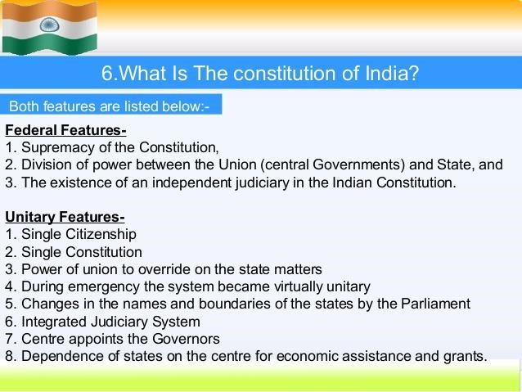

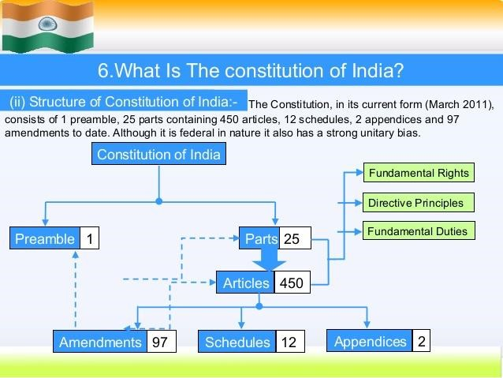

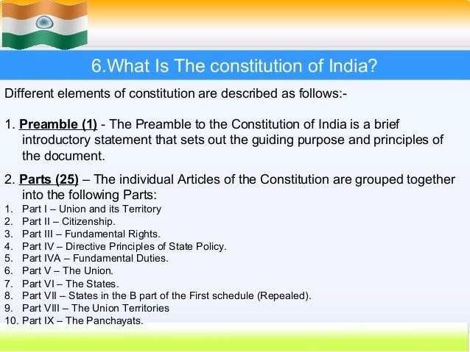

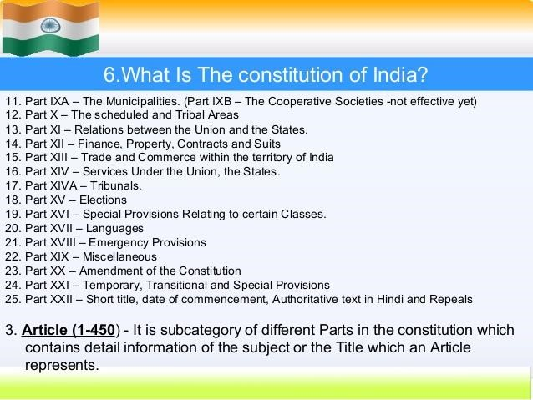

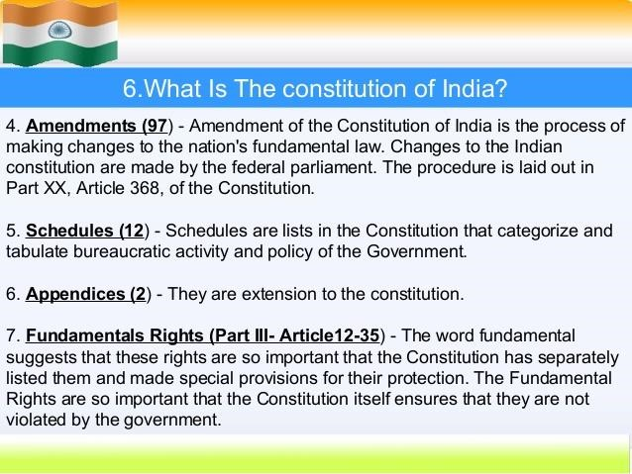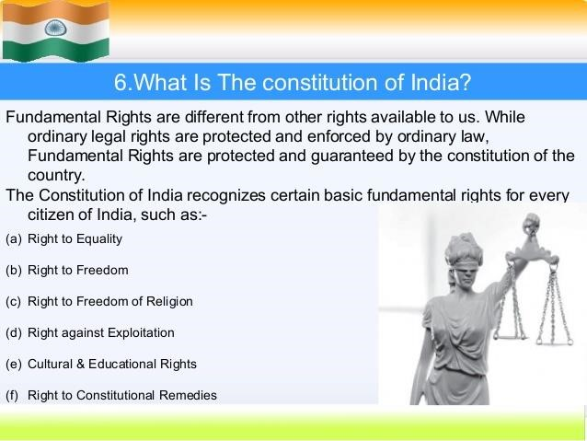

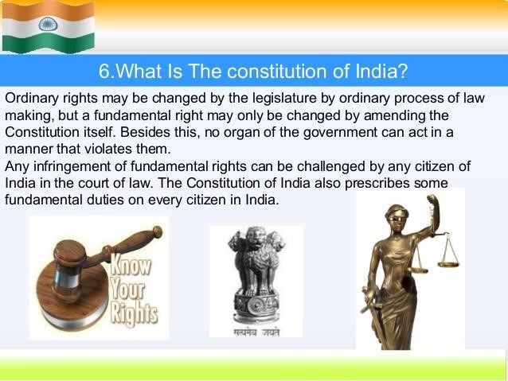

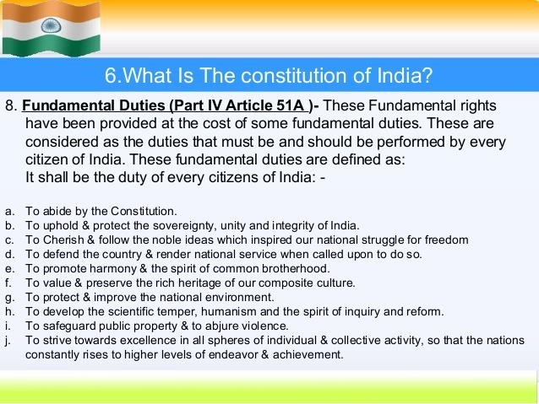

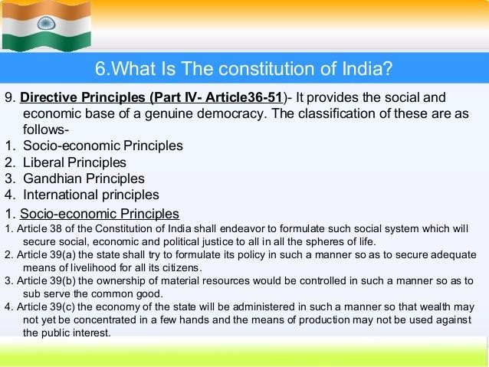

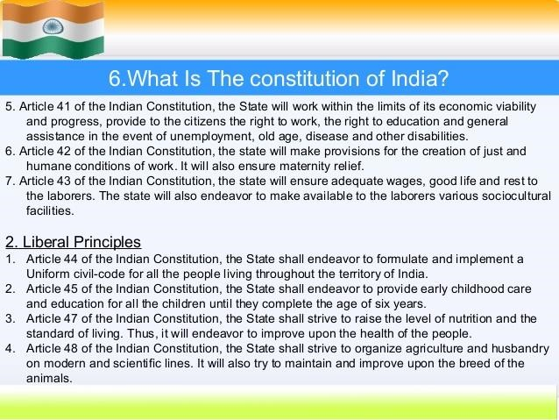

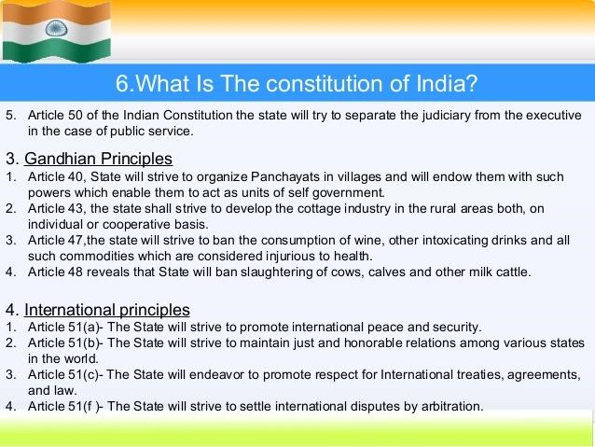

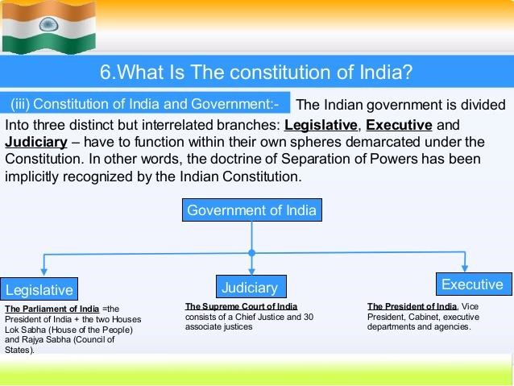

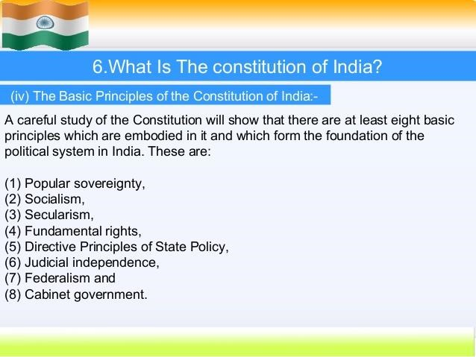

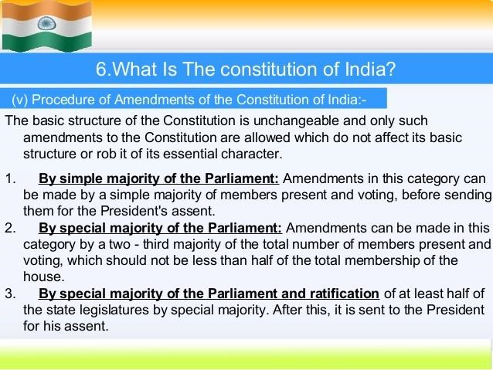

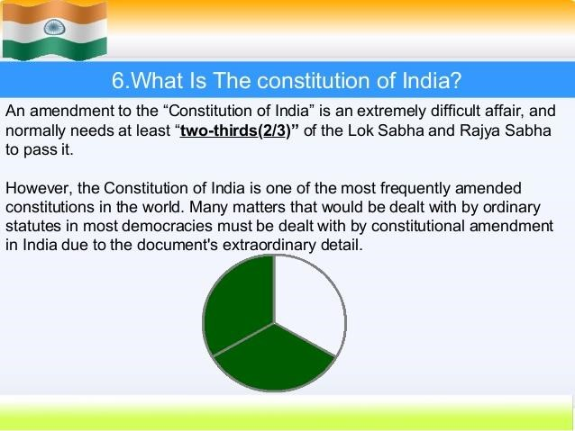

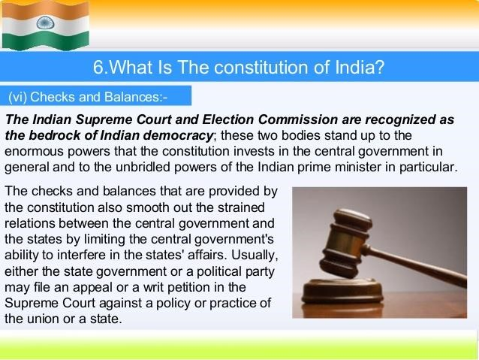

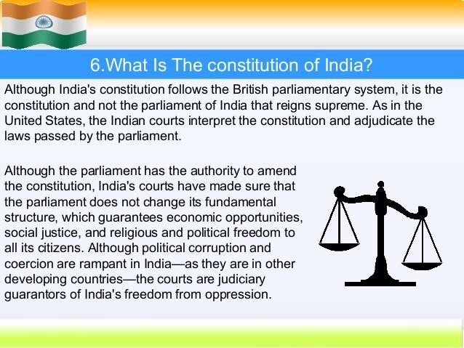

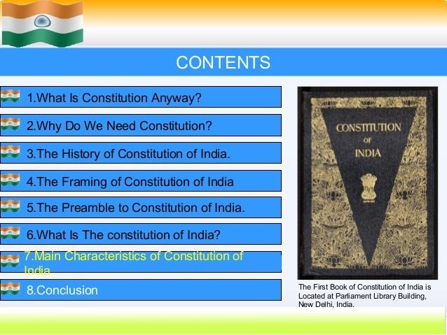

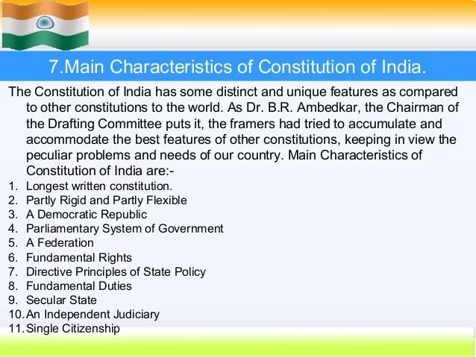

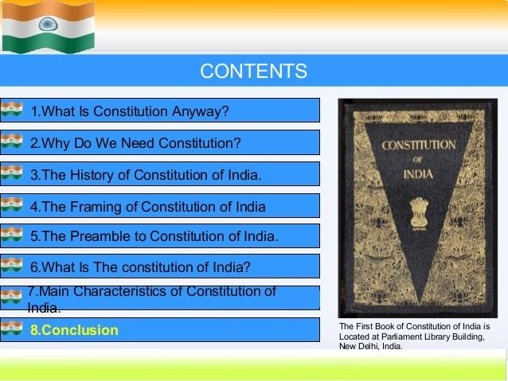

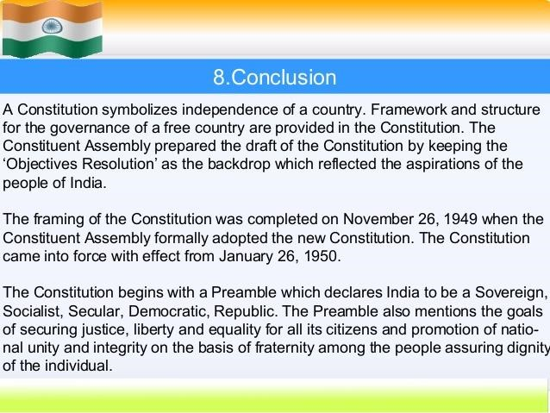

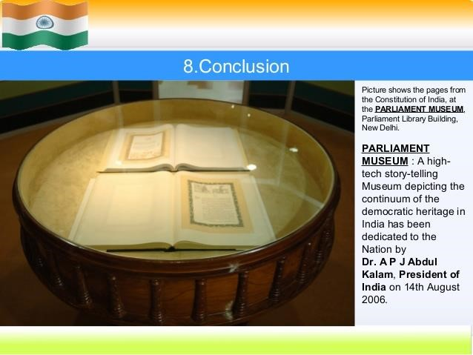

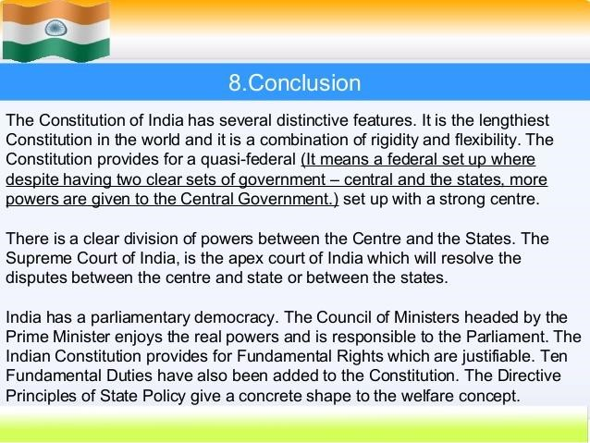

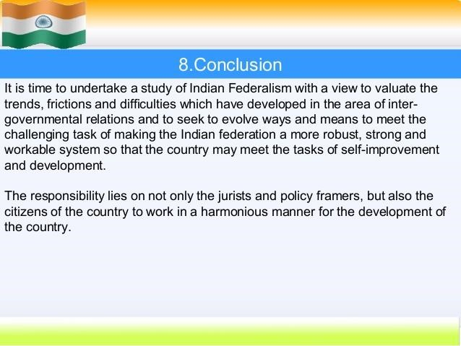

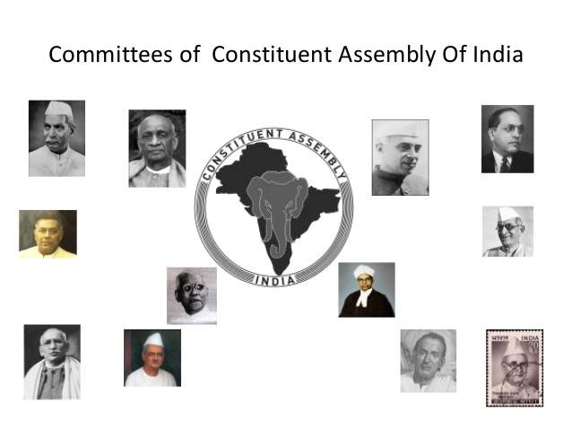

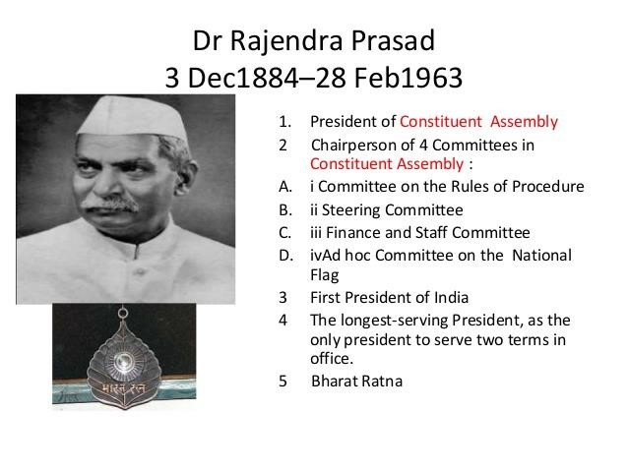

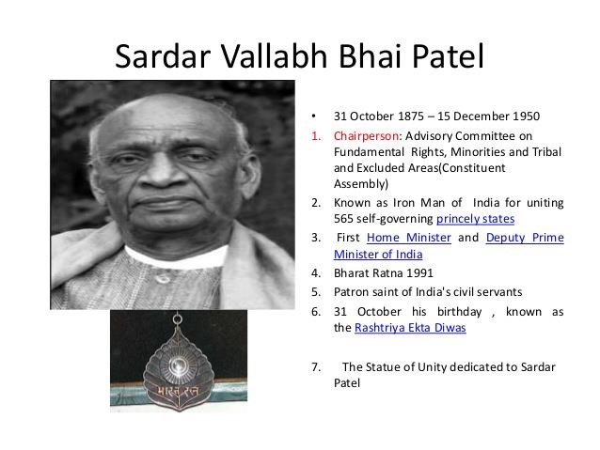

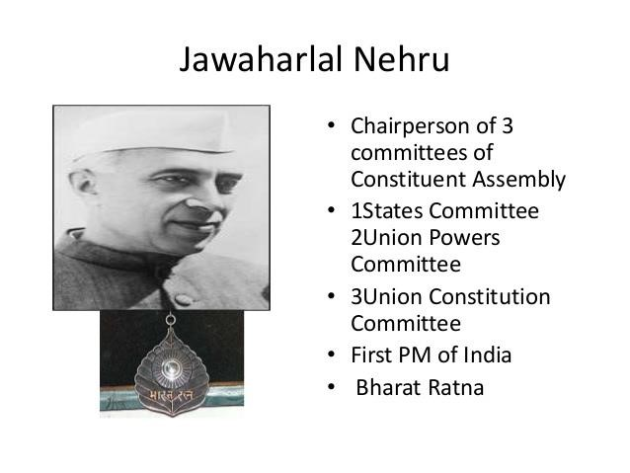

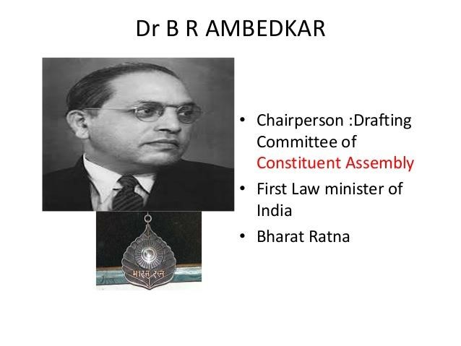

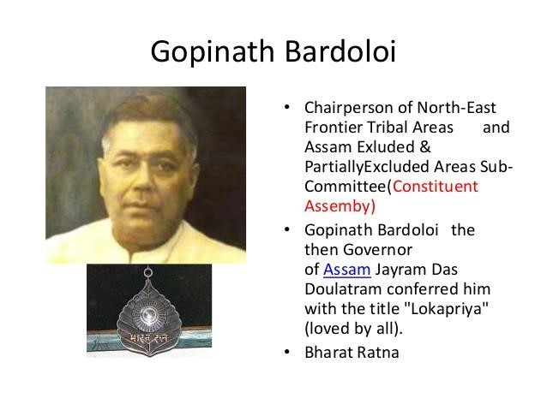

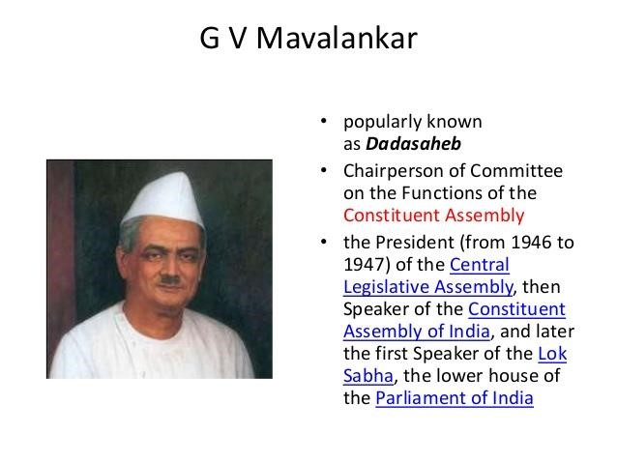

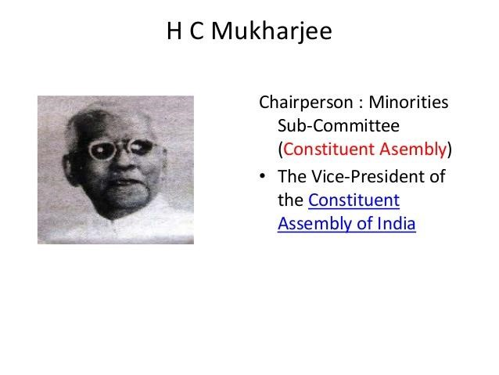

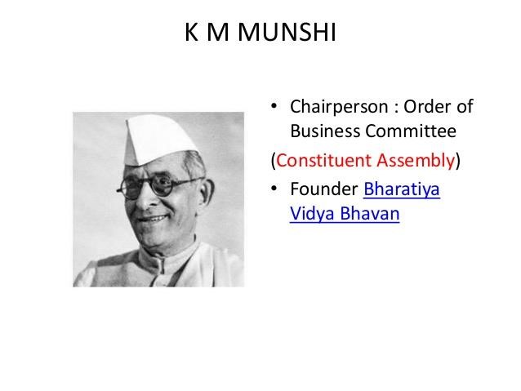

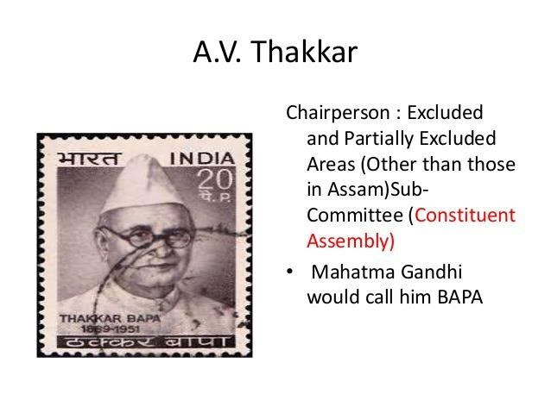

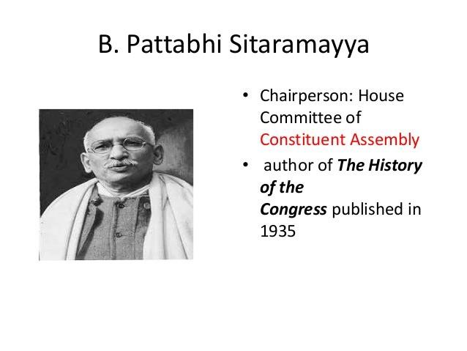

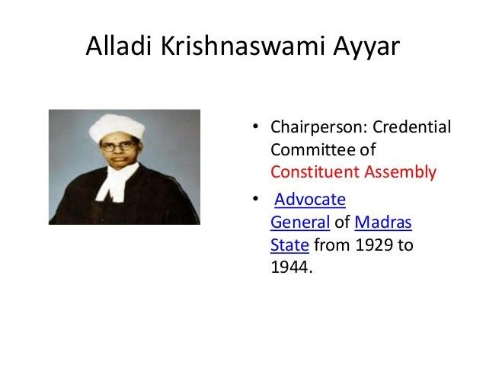

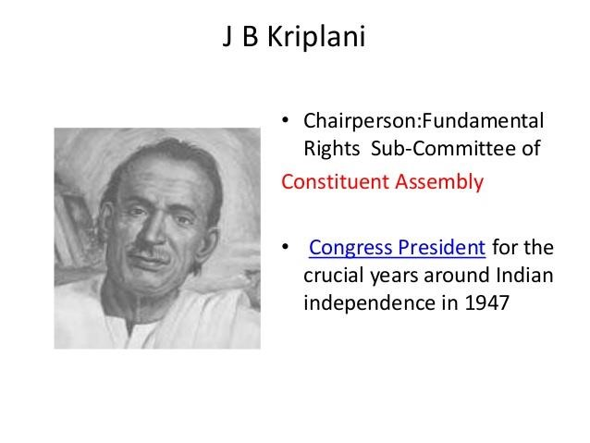

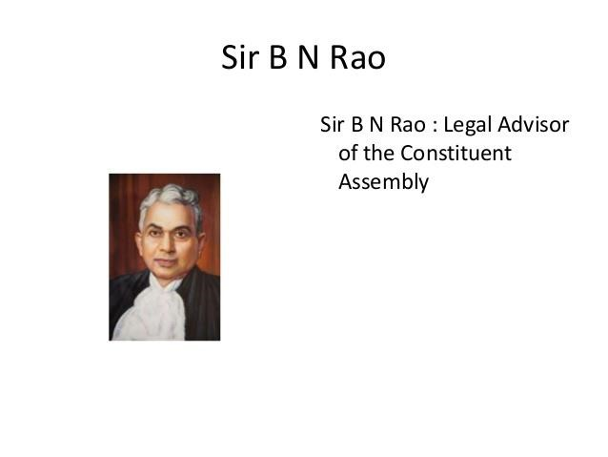

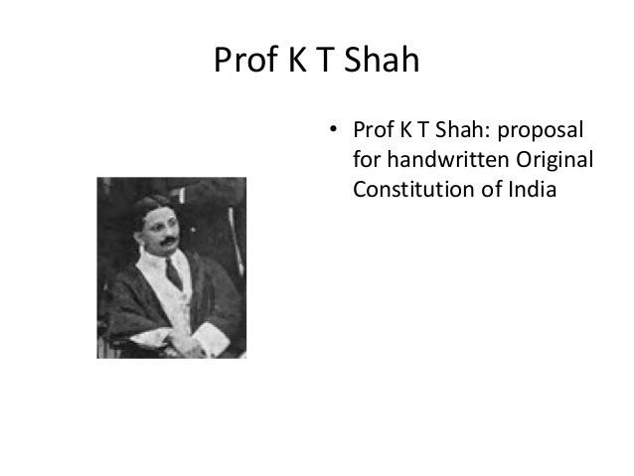

Brief study about Dr*. B. R. Ambedkar*

